Appendix S2 Simulations to show the validity of the null model when sampling effort is constant across communities (this study)

A criticism on the null model used in this study (i.e., the null model β-deviation proposed by Kraft et al. (2011)) is that the β-deviation is subject to the effect of sampling effort (SE) (and thus the regional γ-diversity as well) (Bennett & Gilbert 2016; Ulrich et al. 2017). While this is a legitimate criticism, a practical and more important question is how does the SE-dependence of β-deviation affect among-region comparisons. Or more specifically, whether or not the orders of a series of regions ranked by the β-deviation calculated from the sampled local communities for each region would be altered. If the orders change with SE, then the metric should not be used to compare β-diversity across regions. Otherwise, the metric, though depending on SE itself, should be useful to compare β-diversity under a consistent SE.
Because β-diversity is immediately determined by two factors, namely species abundance distribution (SAD; describing both the number of species and the evenness of abundance among species) and intraspecific aggregation (He & Legendre 2002; Morlon et al. 2008; Xu et al. 2015), here we design a simulation with varying SAD (both number of species and SAD evenness) and intraspecific aggregation to test the effect of SE on among-region comparison. Specifically, we simulated a series of spatially explicit regional communities using the sim_thomas_community function of the mobsim R package (May 2017). All regional communities had the same spatial extent (500×1000) and total abundance (20,000), but they had different number of species (#spp = 100, 200, 400), SAD evenness (controlled using the cv_abund argument in the sim_thomas_community function by assuming a lognormal distribution; cv_abund = 0.5, 1.5, 3), and different degree of intraspecific aggregation (controlled using the sigma argument which defines the mean dispersal distance in the sim_thomas_community function; sigma = infinity (for random distribution), 200, 100, 50, 20). In total, 45 scenarios (regional communities) were simulated. Each of the simulated regional communities was then divided into 50 100×100 local communities (or plots) and the proportional species turnover (β_{P}), standardized β-deviation for β_{P}, and the mean pairwise Jaccard distance were calculated based on the 50 plots. All these indices were also estimated using random subsamples of the 50 plots for each regional community. Four levels of SE (i.e., the number of subsampled plots = 3, 6, 12, 24) were considered. β values estimated using these subsamples were plotted against that calculated from the full 50 plots to check consistency.
The results show that as long as the same sampling effort is applied, the order of the regional communities based on β-deviation estimated from subsamples is consistent with that based on β-deviation calculated from the full data, regardless of the difference in the number of species, SAD evenness, and degree of aggregation (Fig. S2.1). This result is consistent with Bennett & Gilbert (2016) and suggests that β-deviation is effective in comparing different communities as long as sampling effort is constant across communities. Our simulation also reveals that the N-community β measure (i.e., β_{P}), not like β-deviation, may not be comparable for sample data because the bias introduced by sampling is dependent on SAD evenness (Fig. S2.1).
As pointed out by Bennett & Gilbert (2016), the pairwise β-diversity has the desirable property of independence of sampling effort (Fig. S2.1; see also Marion et al. 2017). The problem with the pairwise β-diversity is that it could not serve as a simple substitution for the β-deviation because pairwise β, like the N-community β, does not provide the same insight into community assembly that the null model does. For example, by comparing pairwise β could not reveal anything about the effects of SAD and/or species spatial pattern on shaping community structure, but the null model can successfully distinguish random and aggregated spatial distribution (Fig. S2.2). In this study, we chose to use β-deviation, instead of the pairwise β-diversity, to compare non-random β patterns across assemblages so that to make our work directly comparable to the work in recent debate (Kraft et al. 2011; Qian et al. 2012, 2013; Tuomisto & Ruokolainen 2012; Myers et al. 2013).

References
Bennett, J.R. & Gilbert, B. (2016). Contrasting beta diversity among regions: how do classical and multivariate approaches compare? Glob. Ecol. Biogeogr., 25, 368–377.
He, F. & Legendre, P. (2002). Species diversity patterns derived from species–area models. Ecology, 83, 1185–1198.
Kraft, N.J.B., Comita, L.S., Chase, J.M., Sanders, N.J., Swenson, N.G., Crist, T.O., et al. (2011). Disentangling the drivers of β diversity along latitudinal and elevational gradients. Science, 333, 1755–1758.
Marion, Z.H., Fordyce, J.A. & Fitzpatrick, B.M. (2017). Pairwise beta diversity resolves an underappreciated source of confusion in calculating species turnover. Ecology, 98, 933–939.
May, F. (2017). mobsim: Spatial Simulation and Scale-Dependent Analysis of Biodiversity Changes. R Package Version 0.1.0. Available at: https://CRAN.R-project.org/package=mobsim. Last accessed 26 January 2018.
Morlon, H., Chuyong, G., Condit, R., Hubbell, S., Kenfack, D., Thomas, D., et al. (2008). A general framework for the distance–decay of similarity in ecological communities. Ecol. Lett., 11, 904–917.
Myers, J.A., Chase, J.M., Jiménez, I., Jørgensen, P.M., Araujo-Murakami, A., Paniagua-Zambrana, N., et al. (2013). Beta-diversity in temperate and tropical forests reflects dissimilar mechanisms of community assembly. Ecol. Lett., 16, 151–157.
Qian, H., Chen, S., Mao, L. & Ouyang, Z. (2013). Drivers of β-diversity along latitudinal gradients revisited. Glob. Ecol. Biogeogr., 22, 659–670.
Qian, H., Wang, X. & Zhang, Y. (2012). Comment on “Disentangling the drivers of β diversity along latitudinal and elevational gradients.” Science, 335, 1573–1573.
Tuomisto, H. & Ruokolainen, K. (2012). Comment on “Disentangling the drivers of β diversity along latitudinal and elevational gradients.” Science, 335, 1573–1573.
Ulrich, W., Baselga, A., Kusumoto, B., Shiono, T., Tuomisto, H. & Kubota, Y. (2017). The tangled link between β- and γ-diversity: a Narcissus effect weakens statistical inferences in null model analyses of diversity patterns. Glob. Ecol. Biogeogr., 26, 1–5.
Xu, W., Chen, G., Liu, C. & Ma, K. (2015). Latitudinal differences in species abundance distributions, rather than spatial aggregation, explain beta-diversity along latitudinal gradients. Glob. Ecol. Biogeogr., 24, 1170–1180.
Figure S2.1 Relations of β-diversity/β-deviation estimated using subsamples with that calculated using the full data for a series of simulated regional communities. Each panel shows results for a specific metric (indicated in the above of the first row) assessed at a specific sampling effort (indicated in the right of the third column). The symbol shapes represent number of species with different colors represent evenness of species abundance distribution (SAD). The grey-scale filling of the symbols represents a gradient of intraspecific aggregation from random (white) to highly aggregated (black). The error bars represent 2 SD estimated from repeating the random sampling procedure 100 times. The lines show the one-to-one relationship.
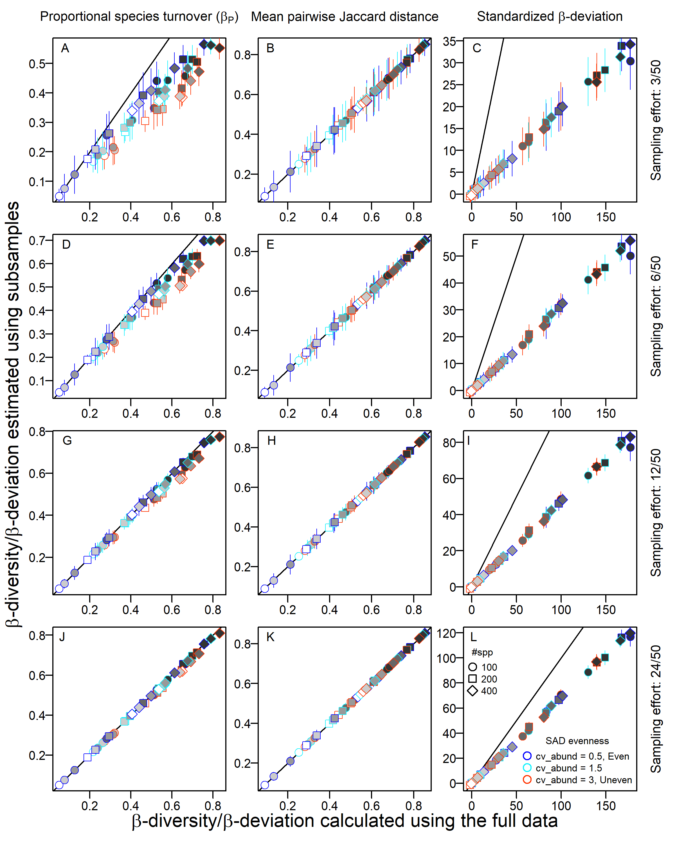Figure S2.2 Relations of different β-diversity/β-deviation indices with evenness of species abundance distribution (SAD) and species spatial pattern for six simulated scenarios (or regional communities; a–f). The number of species (or γ-diversity) for all scenarios shown in this figure was 100. The aggregated species spatial pattern for this figure was simulated using the sim_thomas_community function with sigma = 200. Each boxplot is for 100 repetitions of each of the scenarios.
