SUPPLEMENTAL MATERIAL

Table S1. Information on 60 voucher specimens of 12 recognized and tentative taxa of *Metrosideros* on O`ahu. The first and second set of herbarium voucher specimens representing the 12 taxa are housed (respectively) at the National Tropical Botanical Garden, Kaua`i, and the T. M. Sperry Herbarium at Pittsburg State University.

|  |  |  |  |  |  |  |  |  |  |  |
| --- | --- | --- | --- | --- | --- | --- | --- | --- | --- | --- |
| Collec-tion ID | Taxon name | Taxon code | Date collected | Latitude | Longitude | Elev-ation (m) | Volcano | Leaf type | Collector | Associated collectors |
| O015 | *M. macropus* | M | 11/5/2010 | 21.35507276 | -157.83067077 | 535.00 | Ko`olau | glabrous | J. Johansen | E. Stacy |
| O016 | *M. polymorpha* race C | C | 11/5/2010 | 21.35504167 | -157.83075753 | 536.00 | Ko`olau | pubescent | J. Johansen | E. Stacy |
| O017 | *M. polymorpha* race B | B | 11/5/2010 | 21.36947053 | -157.80942927 | 854.00 | Ko`olau | glabrous | J. Johansen | E. Stacy |
| O018 | *M. polymorpha* var. *glaberrima* | G | 11/5/2010 | 21.36947053 | -157.80942927 | 854.00 | Ko`olau | glabrous | J. Johansen | E. Stacy |
| O019 | *M. rugosa* | R | 11/5/2010 | 21.36748385 | -157.81177947 | 717.00 | Ko`olau | pubescent | J. Johansen | E. Stacy |
| O020 | *M. tremuloides* | T | 11/5/2010 | 21.36370394 | -157.81815282 | 653.00 | Ko`olau | glabrous | J. Johansen | E. Stacy |
| O021 | *M. tremuloides* | T | 11/5/2010 | 21.36266417 | -157.81961546 | 669.00 | Ko`olau | glabrous | J. Johansen | E. Stacy |
| O022 | *M. macropus* | M | 11/5/2010 | 21.36063583 | -157.82399509 | 605.00 | Ko`olau | glabrous | J. Johansen | E. Stacy |
| O023 | *M. polymorpha* var. *incana* | I | 11/6/2010 | 21.60189877 | -157.91619049 | 205.00 | Ko`olau | pubescent | J. Johansen | E. Stacy |
| O024 | *M. polymorpha* var. *glaberrima* | G | 11/6/2010 | 21.60202358 | -157.91605379 | 214.00 | Ko`olau | glabrous | J. Johansen | E. Stacy |
| O025 | *M. polymorpha* var. *incana* | I | 11/6/2010 | 21.60195024 | -157.91625210 | 200.00 | Ko`olau | pubescent | J. Johansen | E. Stacy |
| O027 | *M. polymorpha* var. *incana* | I | 11/6/2010 | 21.59516182 | -157.91819234 | 289.00 | Ko`olau | pubescent | J. Johansen | E. Stacy |
| O028 | *M. polymorpha* var. *glaberrima* | G | 11/6/2010 | 21.59160596 | -157.92008783 | 399.00 | Ko`olau | glabrous | J. Johansen | E. Stacy |
| O029 | *M. polymorpha* var. *incana* | I | 11/6/2010 | 21.59132659 | -157.92017190 | 401.00 | Ko`olau | pubescent | J. Johansen | E. Stacy |
| O030 | *M. polymorpha* var. *glaberrima* | G | 11/6/2010 | 21.58881303 | -157.92111268 | 463.00 | Ko`olau | glabrous | J. Johansen | E. Stacy |
| O046 | M. polymorpha race L | L | 11/7/2010 | 21.41494528 | -157.86343513 | 601.00 | Ko`olau | glabrous | J. Johansen | E. Stacy |
| O070 | *M. polymorpha* race C | C | 11/7/2010 | 21.40883613 | -157.87427394 | 527.00 | Ko`olau | pubescent | J. Johansen | E. Stacy |
| O072 | *M. polymorpha* var. *incana* | I | 11/7/2010 | 21.40881761 | -157.87446538 | 530.00 | Ko`olau | pubescent | J. Johansen | E. Stacy |
| O075 | *M. polymorpha* var. *incana* | I | 11/7/2010 | 21.40838443 | -157.87581277 | 527.00 | Ko`olau | pubescent | J. Johansen | E. Stacy |
| O095 | *M. polymorpha* var. *glaberrima* | G | 12/4/2010 | 21.41346194 | -157.86615749 | 531.00 | Ko`olau | glabrous | J. Johansen | E. Stacy |
| O097 | *M. macropus* | M | 12/4/2010 | 21.41601825 | -157.85622116 | 678.00 | Ko`olau | glabrous | J. Johansen | E. Stacy |
| O099 | *M. rugosa* | R | 12/5/2010 | 21.32816283 | -157.75314546 | 779.00 | Ko`olau | pubescent | J. Johansen | E. Stacy |
| O103 | *M. rugosa* | R | 12/5/2010 | 21.32789511 | -157.75247893 | 778.00 | Ko`olau | pubescent | J. Johansen | E. Stacy |
| O116 | *M. rugosa* | R | 12/5/2010 | 21.32733990 | -157.74930110 | 792.00 | Ko`olau | pubescent | J. Johansen | E. Stacy |
| O176 | *M. polymorpha* race F | F | 2/5/2011 | 21.50687523 | -158.14430902 | 1231.00 | Wai`anae | pubescent | J. Johansen | E. Stacy |
| O211 | *M. tremuloides* | T | 2/5/2011 | 21.50240022 | -158.15295596 | 978.00 | Wai`anae | glabrous | J. Johansen | E. Stacy |
| O236 | *M. macropus* | M | 2/6/2011 | 21.53441682 | -157.92289333 | 749.00 | Ko`olau | glabrous | J. Johansen | E. Stacy |
| O242 | *M. rugosa* | R | 2/6/2011 | 21.53279426 | -157.92092049 | 795.00 | Ko`olau | pubescent | J. Johansen | E. Stacy |
| O347 | *M. polymorpha* race S | S | 5/5/2012 | 21.50255738 | -158.14901328 | 1199.00 | Wai`anae | glabrous | J. Johansen | E. Stacy |
| O1003 | *M. rugosa* | R | 6/10/2013 | 21.32183047 | -157.73078749 | 714.00 | Ko`olau | pubescent | J. Johansen | E. Stacy |
| O350 | *M. polymorpha* race S | S | 5/6/2012 | 21.50252360 | -158.14933246 | 1193.00 | Wai`anae | glabrous | J. Johansen | E. Stacy |
| O1001 | *M. tremuloides* | T | 6/9/2013 | 21.34533660 | -157.80669074 | 523.08 | Ko`olau | glabrous | J. Johansen | E. Stacy |
| O1000 | *M. tremuloides* | T | 6/9/2013 | 21.34533660 | -157.80669074 | 573.08 | Ko`olau | glabrous | J. Johansen | E. Stacy |
| F2 | *M. polymorpha* race F | F | 10/20/2017 | 21.34798494 | -157.79749042 | 675.69 | Ko`olau | pubescent | E Stacy |  |
| F3 | *M. polymorpha* race F | F | 10/20/2017 | 21.34827093 | -157.79729093 | 664.63 | Ko`olau | pubescent | E Stacy |  |
| F4 | *M. polymorpha* race F | F | 10/20/2017 | 21.34824512 | -157.79729714 | 656.46 | Ko`olau | pubescent | E Stacy |  |
| F5 | *M. polymorpha* race F | F | 10/20/2017 | 21.34866555 | -157.79684611 | 661.51 | Ko`olau | pubescent | E Stacy |  |
| Z1 | *M. polymorpha* race Z | Z | 10/20/2017 | 21.32733529 | -157.75386957 | 713.00 | Ko`olau | glabrous | E Stacy |  |
| Z2 | *M. polymorpha* race Z | Z | 10/20/2017 | 21.32743025 | -157.75380386 | 770.00 | Ko`olau | glabrous | E Stacy |  |
| Z3 | *M. polymorpha* race Z | Z | 10/20/2017 | 21.32747007 | -157.75374946 | 769.00 | Ko`olau | glabrous | E Stacy |  |
| Z4 | *M. polymorpha* race Z | Z | 10/20/2017 | 21.32782361 | -157.75189362 | 778.00 | Ko`olau | glabrous | E Stacy |  |
| Z5 | *M. polymorpha* race Z | Z | 10/20/2017 | 21.32999210 | -157.75517832 | 735.00 | Ko`olau | glabrous | E Stacy |  |
| C1 | *M. polymorpha* race C | C | 10/20/2017 | 21.41036851 | -157.87065094 | 536.00 | Ko`olau | pubescent | E Stacy |  |
| C2 | *M. polymorpha* race C | C | 10/20/2017 | 21.41543688 | -157.86240089 | 604.00 | Ko`olau | pubescent | E Stacy |  |
| C3 | *M. polymorpha* race C | C | 10/20/2017 | 21.41536212 | -157.86263240 | 603.00 | Ko`olau | pubescent | E Stacy |  |
| L1 | *M. polymorpha* race L | L | 10/20/2017 | 21.41550000 | -157.86224222 | 605.00 | Ko`olau | glabrous | E Stacy |  |
| L2 | *M. polymorpha* race L | L | 10/20/2017 | 21.41548047 | -157.86233593 | 605.00 | Ko`olau | glabrous | E Stacy |  |
| L3 | *M. polymorpha* race L | L | 10/20/2017 | 21.41544074 | -157.86245051 | 604.00 | Ko`olau | glabrous | E Stacy |  |
| L4 | *M. polymorpha* race L | L | 10/20/2017 | 21.41435679 | -157.86408464 | 588.00 | Ko`olau | glabrous | E Stacy |  |
| B1 | *M. polymorpha* race B | B | 10/20/2017 | 21.41685435 | -157.85403902 | 746.00 | Ko`olau | glabrous | E Stacy |  |
| B2 | *M. polymorpha* race B | B | 10/20/2017 | 21.32236113 | -157.73076536 | 735.00 | Ko`olau | glabrous | E Stacy |  |
| B3 | *M. polymorpha* race B | B | 10/20/2017 | 21.32286463 | -157.73143223 | 708.00 | Ko`olau | glabrous | E Stacy |  |
| B4 | *M. polymorpha* race B | B | 10/20/2017 | 21.32867287 | -157.75363203 | 740.34 | Ko`olau | glabrous | E Stacy |  |
| B5 | *M. polymorpha* race B | B | 10/20/2017 | 21.32926798 | -157.75458757 | 739.61 | Ko`olau | glabrous | E Stacy |  |
| A1 | *M. polymorpha* race *prostrata* | A | 10/20/2017 | 21.42034113 | -157.84911867 | 759.00 | Ko`olau | glabrous | E Stacy |  |
| A2 | *M. polymorpha* race *prostrata* | A | 10/20/2017 | 21.42034113 | -157.84911867 | 759.00 | Ko`olau | glabrous | E Stacy |  |
| A3 | *M. polymorpha* race *prostrata* | A | 10/20/2017 | 21.42034113 | -157.84911867 | 759.00 | Ko`olau | glabrous | E Stacy |  |
| A4 | *M. polymorpha* race *prostrata* | A | 10/20/2017 | 21.42088839 | -157.84643755 | 836.00 | Ko`olau | glabrous | E Stacy |  |
| A5 | *M. polymorpha* race *prostrata* | A | 10/20/2017 | 21.42088839 | -157.84643755 | 836.00 | Ko`olau | glabrous | E Stacy |  |
| A6 | *M. polymorpha* race *prostrata* | A | 10/20/2017 | 21.42088839 | -157.84643755 | 836.00 | Ko`olau | glabrous | E Stacy |  |

Table S2. Summary of classification from discriminant analysis of 971 common-garden plants of eight *Metrosideros* taxa from O`ahu. Analysis was done using 11 characters: mean leaf length, mean leaf width, mean leaf shape, mean petiole length, leaf curvature score, rugosity score, abaxial pubescence score, adaxial pubescence score, pigmentation score, leaf area, and specific leaf area. Eighty-seven of 97 (89.7%) plants were correctly classified to taxon.

|  |  |  |  |  |  |  |  |  |
| --- | --- | --- | --- | --- | --- | --- | --- | --- |
|  | True Group | | | | | | | |
| Put into group | B | C | G | I | L | M | R | T |
| B | 9 | 0 | 0 | 0 | 0 | 0 | 0 | 0 |
| C | 0 | 8 | 0 | 2 | 0 | 0 | 0 | 0 |
| G | 1 | 0 | 5 | 0 | 1 | 0 | 0 | 0 |
| I | 0 | 2 | 0 | 20 | 0 | 0 | 0 | 0 |
| L | 1 | 0 | 0 | 0 | 15 | 0 | 0 | 2 |
| M | 0 | 0 | 0 | 0 | 0 | 5 | 0 | 0 |
| R | 0 | 0 | 0 | 0 | 0 | 0 | 14 | 0 |
| T | 0 | 0 | 0 | 0 | 1 | 0 | 0 | 11 |
| Total N | 11 | 10 | 5 | 22 | 17 | 5 | 14 | 13 |
| N correct | 9 | 8 | 5 | 20 | 15 | 5 | 14 | 11 |
| Proportion | 0.818 | 0.800 | 1.000 | 0.909 | 0.882 | 1.000 | 1.000 | 0.846 |

1The lower sample size was due to the small size of four plants, from which leaves were not collected for

calculation of SLA.

Table S3. Linear discriminant function coefficients for each of eight *Metrosideros* taxa from O`ahu based on 11 morphological traits: mean leaf length (MLL), mean leaf width (MLW), mean leaf shape (MLS), mean petiole length (MPL), leaf curvature score (LCS), rugosity score (RS), abaxial pubescence score (AbPS), adaxial pubescence score (AdPS), pigmentation score (PS), leaf area, and specific leaf area (SLA).

|  |  |  |  |  |  |  |  |  |
| --- | --- | --- | --- | --- | --- | --- | --- | --- |
|  | B | C | G | I | L | M | R | T |
| Constant | -89.25 | -176.66 | -87.09 | -174.04 | -86.44 | -144.34 | -337.70 | -109.41 |
| MLL (cm) | -10.89 | -21.81 | -14.89 | -17.66 | -9.02 | -15.17 | -22.15 | -9.58 |
| MLW (cm) | 41.43 | 48.70 | 42.34 | 41.93 | 31.56 | 45.15 | 42.99 | 33.89 |
| MLS | 41.54 | 44.82 | 42.41 | 40.67 | 39.11 | 41.18 | 42.45 | 49.09 |
| MPL (cm) | 1.77 | 11.62 | 21.51 | 11.73 | 21.81 | 78.85 | 13.42 | 26.23 |
| LCS (0-3) | 7.97 | 13.48 | 5.65 | 7.35 | 5.07 | 5.18 | 9.98 | 5.35 |
| RS (0-2) | -12.67 | -5.01 | -13.91 | -7.57 | -14.02 | -13.34 | 38.22 | -12.65 |
| AbPS (0-3) | -3.99 | 104.97 | -7.85 | 107.78 | -7.57 | -2.36 | 168.01 | -6.48 |
| AdPS (0-1) | 13.31 | -0.22 | 8.31 | -1.15 | 9.47 | 8.44 | -7.33 | 12.31 |
| PS (1-3) | 6.53 | 3.44 | 5.75 | 2.63 | 6.26 | 5.63 | -0.31 | 4.78 |
| LA (cm2) | -0.10 | -0.07 | 0.15 | -0.07 | 0.15 | 0.17 | -0.13 | 0.03 |
| SLA (cm2/g) | 0.66 | 0.38 | 0.54 | 0.61 | 0.66 | 0.54 | 0.23 | 0.73 |

Table S4. Linear discriminant function coefficients for glabrous and pubescent groups of *Metrosideros* taxa from O`ahu based on nine morphological traits: mean leaf length (MLL), mean leaf width (MLW), mean leaf shape (MLS), mean petiole length (MPL), leaf curvature score (LCS), rugosity score (RS), pigmentation score (PS), leaf area (LA), and specific leaf area (SLA).

|  |  |  |
| --- | --- | --- |
|  | Glabrous | Pubescent |
| Constant | -76.298 | -69.973 |
| MLL (cm) | -13.618 | -18.862 |
| MLW (cm) | 37.422 | 43.658 |
| MLS | 38.838 | 39.261 |
| MPL (cm) | -0.078 | -3.188 |
| LCS (0-3) | 7.192 | 9.511 |
| RS (0-2) | 1.201 | 1.819 |
| PS (1-3) | 7.918 | 6.741 |
| LA (cm2) | 0.101 | 0.011 |
| SLA (cm2/g) | 0.490 | 0.510 |

Table S5. Pairwise FST values for all combinations of 12 *Metrosideros* taxa on O`ahu. Individuals are pooled within taxa. Full taxon names are in Table 1.

|  |  |  |  |  |  |  |  |  |  |  |  |
| --- | --- | --- | --- | --- | --- | --- | --- | --- | --- | --- | --- |
|  | M | R | T | Z | F | G | I | L | S | B | A |
| M |  |  |  |  |  |  |  |  |  |  |  |
| R | 0.1561 |  |  |  |  |  |  |  |  |  |  |
| T | 0.1830 | 0.1374 |  |  |  |  |  |  |  |  |  |
| Z | 0.1394 | 0.0807 | 0.0588 |  |  |  |  |  |  |  |  |
| F | 0.1480 | 0.0235 | 0.0963 | 0.0605 |  |  |  |  |  |  |  |
| G | 0.1234 | 0.0530 | 0.0584 | 0.0223 | 0.0243 |  |  |  |  |  |  |
| I | 0.1304 | 0.0594 | 0.0509 | 0.0298 | 0.0206 | 0.0036 |  |  |  |  |  |
| L | 0.1293 | 0.0789 | 0.0422 | 0.0161 | 0.0436 | 0.0171 | 0.0145 |  |  |  |  |
| S | 0.2668 | 0.1810 | 0.1015 | 0.1030 | 0.1228 | 0.0938 | 0.0979 | 0.0747 |  |  |  |
| B | 0.1247 | 0.0898 | 0.0947 | 0.0626 | 0.0759 | 0.0500 | 0.0452 | 0.0488 | 0.1789 |  |  |
| A | 0.1750 | 0.0542 | 0.1407 | 0.0958 | 0.0429 | 0.0677 | 0.0703 | 0.0775 | 0.1811 | 0.1098 |  |
| C | 0.1381 | 0.0461 | 0.0789 | 0.0459 | 0.0117 | 0.0100 | 0.0061 | 0.0264 | 0.1019 | 0.0585 | 0.0574 |

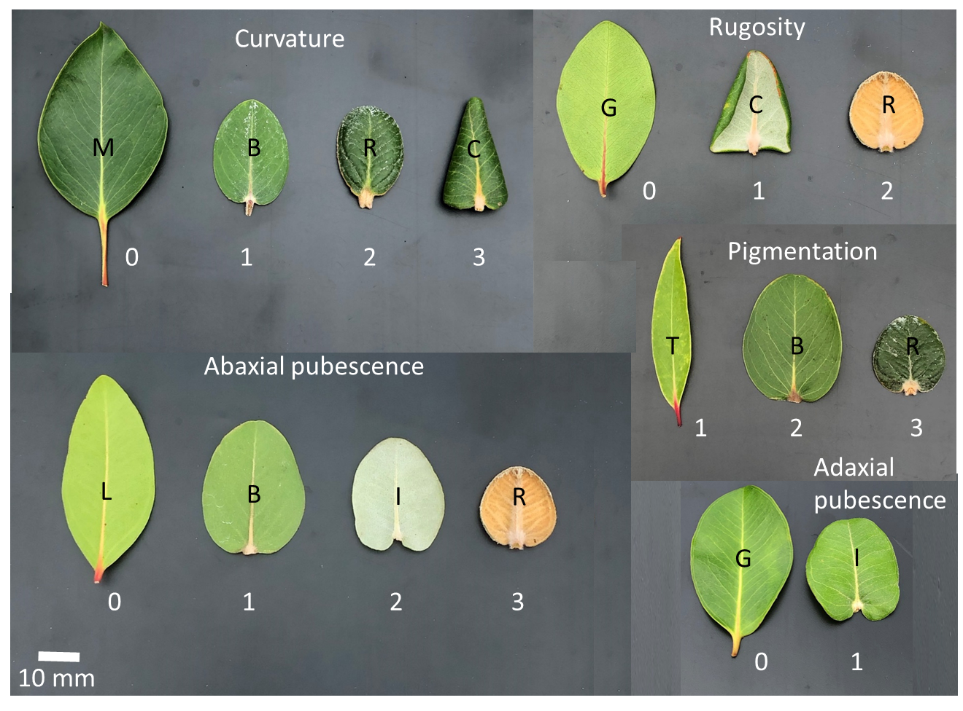

Fig. S1. Representative examples of scores (white text) used for each of five qualitative leaf characters. The taxon code for each example leaf is shown in black text. Leaves of C, I and R are pubescent; all others are glabrous. Full taxon names are in Table 1.



Fig. S2. All waypoints recorded for *Metrosideros* adults on Wai`anae Volcano, O`ahu.

Fig. S3. Morphology of 101 common-garden plants representing eight *Metrosideros* taxa from O`ahu: A) interval-scale measures (mean ± 95% CI), and B) ordinal-scale measures (median, quartiles and range). Pubescent taxa are indicated by *, and monotypic species are underlined. Shared superscripts indicate no statistical difference at family α = 0.2 for Kruskal-Wallis tests and α = 0.05 for one-way ANOVA; df for all Kruskal-Wallis tests = 7; df for leaf width = 7,91; df for SLA = 7,89; p-values for all tests = < 0.001. Full taxon names are in Table 1.

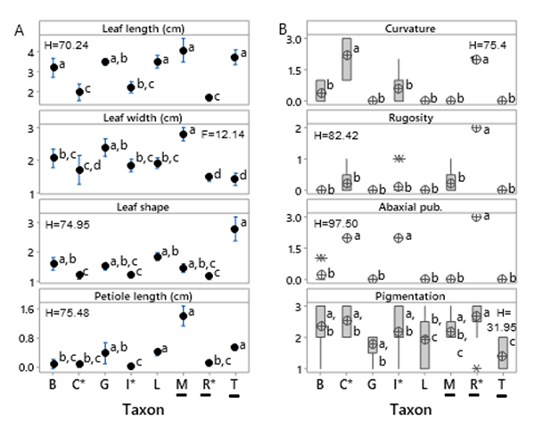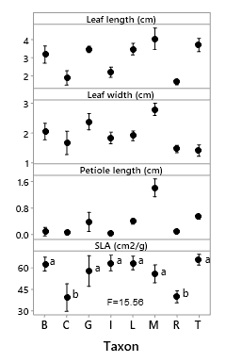

1

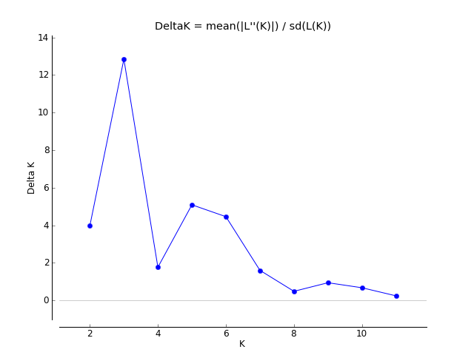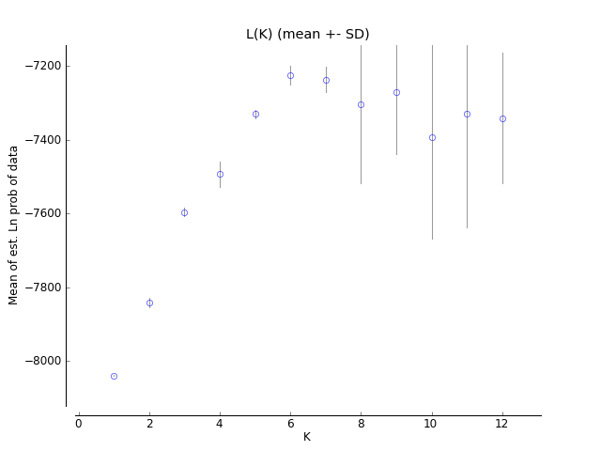 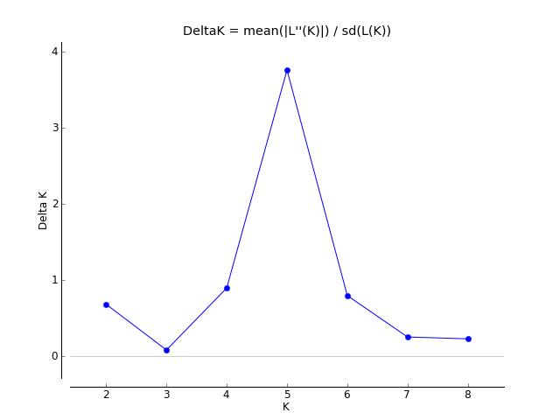 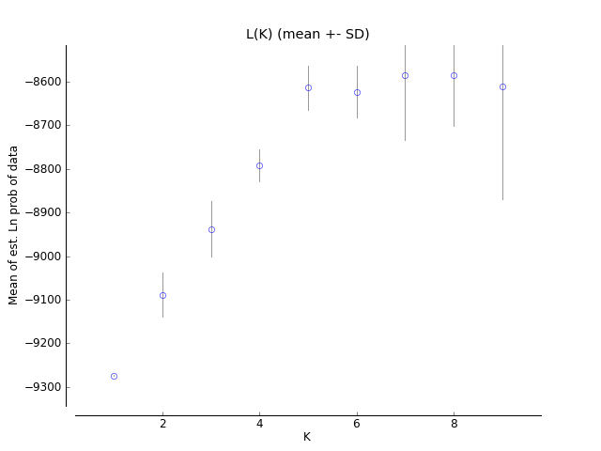

A

B

Fig. S4. Plots of delta K (left) and ln Pr(X|K) (mean ± SD; right) for each of K=1 through Kmax for A) all glabrous *Metrosideros* taxa on O`ahu minus *M. polymorpha* race *prostrata*, and B) all pubescent taxa plus *M. polymorpha* race *prostrata*.

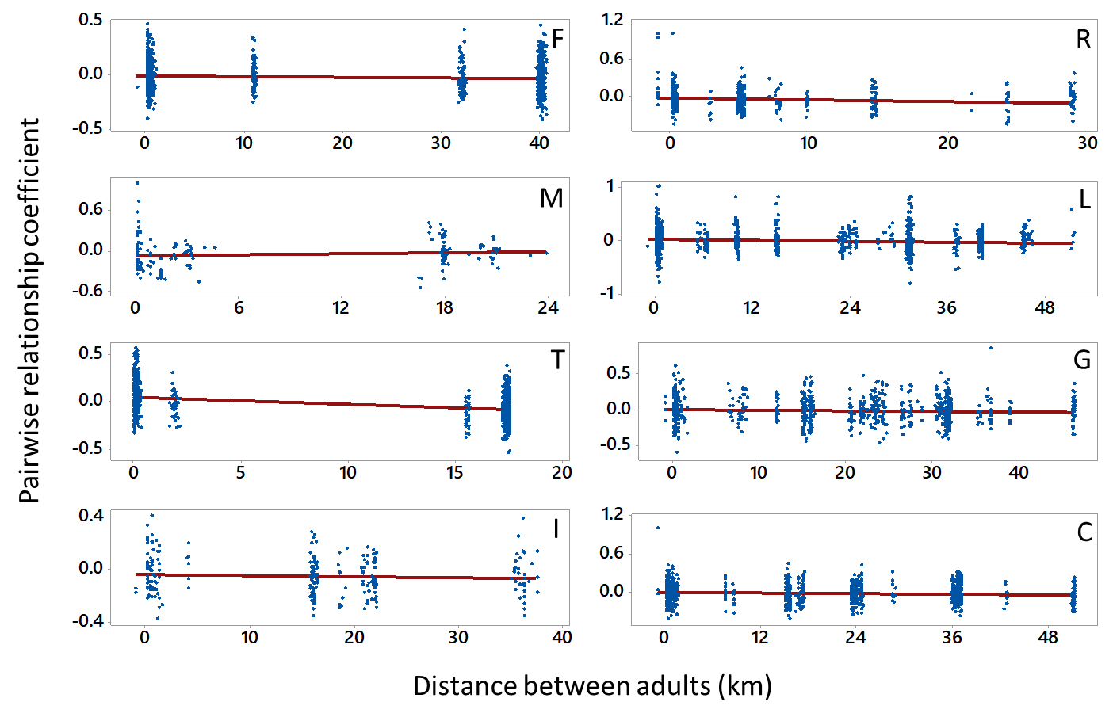

Fig. S5. Relationship between pairwise relationship coefficient and distance for adults of each of eight *Metrosideros* taxa on O`ahu. There is no pattern of isolation by distance for any taxon. Full taxon names are in Table 1.





Fig. S6. Relationship between pairwise relationship coefficient (Queller and Goodnight 1989) and geographic distance between adults along each of three Ko`olau leeward ridges (elevation gradients). Shown are data for pubescent taxa only.

APPENDIX

**Tentative key to species, varieties, and morphological forms of *Metrosideros* on** **O`ahu**

This tentative key is based on extended field observations by the first author and associates (Fig. 3). It uses names for taxa that can be confidently matched to current descriptions and type specimens (Dawson and Stemmermann 1990) and the term “race” for those forms for which the appropriate names (based on a type specimen) have not been resolved. The characters indicated here are based on our collections and field observations and may depart to some degree from those recognized for taxa accepted in Dawson and Stemmermann (1990). Unlike many keys, this key includes observations from the field that typically are unavailable, or are cryptic, on dried herbarium specimens (Snow 1997), such as the color of fresh material, predominant elevation range (based on field observations; see Fig. 4 in main text), and position on the landscape. *In sicco* and *in vivo* refer to dried and living material, respectively. The color of flowers (predominantly stamens, also style and petals) is red unless specified otherwise. Descriptive terminology (including those for shapes, indumentum, and colors) follows Beentje (2010).

1. Lower surface of (fully developed) leaves glabrous (=hairless).…………………….……………..……2

1. Lower surface of (fully developed) leaves densely hairy………………...……….………………….….9

2. Petioles > 6 mm long, narrowly sulcate (=grooved) distally.…………………………………..……..…3

2. Petioles 4 mm or less long ….……………………..…………….………………….……….……..……4

3. Petioles 6–10 mm long, typically somewhat winged distally; leaf blades 2.5–4.5 x 0.7–1.5 cm, narrowly elliptic, base narrowly cuneate, apex attenuate; occurring on steep windy slopes

………………………………………………………………………………………….. *M. tremuloides*

3. Petioles 15–35 mm long, lacking wings distally; leaf blades elliptic to ovate 5.5–8.0 x 2.0–5.0 cm, base slightly cuneate, apex acute (or sometimes slightly falcate-twisted)……………….….….. *M. macropus*

4. Plants prostrate with upright stems mostly < 15 cm tall; leaf blades (0.5–)1.2–2.6 x (0.4–)0.8–1.4 cm.……………...…..……………………………………………….….. *M. polymorpha* race *prostrata*

4. Plants erect and stems > 15 cm tall; leaf blade dimensions mostly greater than 2.6 x 1.4 cm….…….…5

5. Inflorescence axis (especially on emergence) and hypanthium (=area below petals) densely silvery pubescent; Ko`olau Volcano only ……………………………………………... *M. polymorpha* race B

5. Inflorescence axis and hypanthium glabrous (or hypanthium sericeous proximally becoming glabrous in fruit)…………………………………………………………………………………..…….………..6

6. Hypanthium sparsely sericeous (=appressed short-hairy) proximally becoming glabrous in fruit; leaf blades 1.3–2.4 x 0.8–2.0 cm, narrowly elliptic to elliptic or obovate….……...... *M. polymorpha* race Z

6. Hypanthium and fruit glabrous; leaf blades mostly greater than 2.5 x 2.0 cm, never narrowly elliptic…7

7. Plants restricted to summit of Wai`anae Volcano (>1,100 m); petioles up to 4 mm long; apex of leaf buds ovoid……………………………………………..…………..……………. *M. polymorpha* race S

7. Plants on Wai`anae or Ko`olau Volcano (ca. 400–1,000 m); petioles all >3 mm; apex of buds rounded …………………………………………………………………………………………………….……8

8. Emerging leaves deep burgundy or magenta; upper surface of petiole typically with a slight longitudinal ridge proximally (= towards the base); leaf blades (2.0–)2.5–3.7 x (1.0–)1.5–2.4 cm (tending towards the lesser dimensions indicated), elliptic, base mostly cuneate to less frequently rounded, apex obtuse (mostly) to acute; elevation > ca. 590 m (Ko`olau) and > 1,100 m (Wai`anae) ……………………...………………………….…………………….…….…… *M. polymorpha* race L

8. Emerging leaves pinkish to lighter magenta; upper surface of petioles typically sulcate (grooved) distally (=near apex); leaf blades (2.0–)2.5–6.5 x 1.1–3.4 cm (tending towards the greater dimensions indicated), ovate to mostly elliptic-oblong, base rounded (infrequently truncate or slightly cordate), apex obtuse to acute; elevation < ca. 640 m on Ko`olau leeward ridges and < ca. 1,000 m on Wai`anae Volcano……………………………………...….…………. *M. polymorpha* var. *glaberrima*

9 (1). Pubescence on midvein of lower leaf surface less frequently distinctly straighter, longer or more erect compared to the more compacted and shorter pubescence of the blades; leaf blades stiffly coriaceous………….……………………………………………………………….…………………10

9. Pubescence on midvein of lower leaf surface typically straighter, longer and more erect (especially towards the base) compared to the more compacted and shorter pubescence of the blades; leaf blades coriaceous to stiffly coriaceous……………………………………….…………………………………………….………11

10. Leaf margin (or most of blade from midvein outward) strongly recurved to revolute (or rarely nearly conduplicate); secondary veins (in sicco) of upper leaf surface slightly projecting; indumentum of lower leaf surface pubescent (i.e., hairs mostly straight and more or less erect) on midvein, shorter and lanate on blades; < ca. 620 m on Ko`olau Volcano and < ca. 930 m on Wai`anae Volcano ……………....………………………………………………………………….. *M. polymorpha* race C

10. Leaf margins stiffly but only slightly recurved; secondary veins (in sicco) of upper leaf surface (typically strongly) impressed (especially the more proximal ones); indumentum of lower leaf surface more or less uniformly sericeous-lanate on midvein and blade and of only slightly greater length towards base of midvein; > ca. 600 m on Ko`olau Volcano and > ca. 940 m on Wai`anae Volcano ………………………………….…………………………………………..…… *M. polymorpha* race F

11. Leaf margin moderately and stiffly recurved; secondary veins (in sicco) of upper leaf surface (typically strongly) impressed (especially the more proximal ones) and projecting prominently to the margins on lower surface; hairs of upper leaf surface dense typically russet (reddish-brown) to buff (dull yellow-brown) in color; plants along the backbone of Ko`olau Volcano, extending slightly down leeward ridges impacted directly by trade winds……………..………………………………*M. rugosa*

11. Leaf margin (usually) flat to slightly recurved; secondary veins (in sicco) of upper leaf blade surface usually slightly projecting; hairs of lower leaf surface uniformly (on midvein and blade) shortly lanate and grayish; restricted to lower (drier) elevations…….……………………*M. polymorpha* var. *incana*

**Key field traits of *Metrosideros* on O`ahu.**

*Metrosideros macropus*: Shrubs or tree-like shrubs 1.5-4(–7) m; leaf blades glabrous; unmistakable by its long petioles (1.5–3.5 cm) and relatively large and broadly ovate, blades (up to 7 x 5 cm), young leaf buds somewhat mucilaginous when crushed; petals typically yellow or occasionally red; uncommon, typically occurring in scattered groups of one to a few individuals in wet forest; ca. 480–780 m on Ko`olau Volcano, predominantly >1,000 m on Wai`anae Volcano.

*Metrosideros polymorpha* var. *glaberrima*: Shrubs, tree-like shrubs, or trees 1.5–7 m; leaf blades glabrous; emerging leaves and branchlets pinkish to magenta; upper surface of petiole somewhat grooved towards the base; blades up to 6.5 x 3.4 cm, the base rounded (or truncate or cordate), the apex obtuse to acute; inflorescence axis glabrous; ca. 400–640 m on Ko`olau leeward ridges, ca. 650–1,000 m on Wai`anae Volcano.

*Metrosideros polymorpha* var. *incana*: Shrubs, tree-like shrubs, or trees 1.5–7 m; leaf blades densely hairy below; secondary veins of the upper leaf surface flush; the hairs at the base of the midvein on lower surface typically distinctly longer and straighter than the hairs on the adjacent blade; leaf surface flat, the margin flat to slightly recurved; ca. 290–550 m on Ko`olau leeward ridges, known from lower elevations on Wai`anae Volcano but possibly more widespread.

*Metrosideros polymorpha* race *prostrata*: Prostrate shrubs, the stems growing more or less horizontal and branches growing vertically, mostly less than 15 cm tall, and typically enshrouded in thick moss (the leaves and flowers emerging just above the mossy layers); leaves glabrous, < 1.6 cm long, dark green (in vivo); horizontal stems typically hidden under thick moss; restricted to high-elevation sites on leeward ridges exposed to extreme wind; ca. 740–800 m (or higher; J. Lau, pers. comm.) on Ko`olau Volcano.

*Metrosideros polymorpha* race B: Shrubs 1.5–2.5 m; emerging leaves pubescent but becoming

glabrous at maturity; inflorescence axis and hypanthium silvery-pubescent; flowering predominantly December and January; ca. 680–950 m on Ko`olau Volcano along the backbone, extending down leeward ridges.

*Metrosideros polymorpha* race C: Trees 3–7 m; leaves hairy (hairs whitish or cream-colored), the margins strongly recurved or upper surface nearly entirely recurved, upper surface often dark green (in vivo), the secondary veins sometimes impressed towards base of blade (less so in sicco); hypanthium densely lanate with whitish hairs; flowers relatively large and firm (not thinly membranous), ca. 480–620 m on Ko`olau leeward ridges, ca. 680–930 on Wai`anae Volcano.

*Metrosideros polymorpha* race F: Atree or tree-like shrub 1.5–3 m; leaves hairy, the margins stiff but only slightly recurved; secondary veins of upper leaf surface strongly impressed, especially those near base of blade (typically less strongly impressed as in *M. rugosa*); on Wai`anae Volcano young leaves often maroon-magenta, pubescence often extending to upper leaf surface and margin; inflorescence axis densely hairy, with the hairs longer than and the inflorescence axis thicker than that of race B; ca. 600–700 m along Ko’olau leeward ridges and 940 m to summit of Wai`anae Volcano.

*Metrosideros polymorpha* race L; Shrubs or tree-like shrubs 2–3 m; leaves not or only slightly congested at branch tips (many internodes > 5 mm [compare below with race Z]), leaves glabrous, typically greater than 2.5 cm long, margins flat; emerging leaves deep burgundy or magenta; crown markedly uneven in profile and often carrying a substantial load of psyllid galls; inflorescence axis somewhat thin like that of race B but glabrous and the base of blade cuneate to rounded (vs. rounded to cordate in race B); flowers typically red but may be orange or yellow; ca. 550–850 m on Ko`olau leeward ridges and summit of Wai`anae Volcano (Mt. Ka`ala), occasionally lower.

*Metrosideros polymorpha* race S: Shrubs or tree-like shrubs 1.5–2 m; leaf bud up to 2.5 cm long, the apex ovoid; petioles up to 4 mm long; leaf blades (1.0–)1.5–4.5 x 1.2–3.1 cm, glabrous, base rounded or slightly cuneate, margins flat; restricted to summit of Wai`anae Volcano (Mt. Ka`ala).

*Metrosideros polymorpha* race Z: Tree-like shrubs 1–2 m with an even dome-like crown (resembling the top of cultivated broccoli); leaves typically congested at branch tips (many to most internodes < 5 mm), glabrous, less than 2.5 cm long, the margins flat, typically free of galls; emerging leaves green; hypanthium sparsely sericeous but fruits glabrous; flowers red, orange or yellow; ca. 650–780 m, reaching the backbone on Ko`olau Volcano and summit of Wai`anae (Mt. Ka`ala).

*Metrosideros rugosa*: Shrubs or tree-like shrubs 1.5–3 m; upper leaf blade surface often dark green (in vivo), the secondary veins prominent but deeply impressed; leaf blades densely hairy below, the hairs typically reddish-brown to yellowish-brown, and those of the base and lower part of the lower midvein somewhat longer or straighter compared to those of the blade itself; leaf margin moderately and stiffly recurved; ca. 650–860 m on Ko`olau Volcano, along the backbone, extending slightly down leeward ridges impacted directly by trade winds.

*Metrosideros tremuloides*: Shrubs, tree-like shrubs, or trees 1.5–7 m; branches relatively thin and pendant, often somewhat tangled amongst themselves; leaf blades glabrous; easily distinguishedby its relatively long petioles (0.6–1.0 cm) narrowly elliptic, blades with cuneate bases and attenuate apices, leaves larger on Wai`anae; predominantly on steep windy slopes of eroded ridges of both Volcanoes; ca. 500–720 m on Ko`olau Volcano, ca. 900–1,000 m on Wai`anae Volcano.