Journal of Biogeography

SUPPORTING INFORMATION

Phylogenetic conservatism of species range size is the combined outcome of phylogeny and environmental stability

Axelle Zacaï, Emmanuel Fara, Arnaud Brayard, Rémi Laffont, Jean-Louis Dommergues and Christian Meister

Appendix S1 References for Table 1, palaeocoordinates of the 104 studied fossil localities and species-level phylogenetic trees for each chronozone of the early Pliensbachian with and without branch length recalculation

References for Table 1
Abellán, P. & Ribera, I. (2011) Geographic location and phylogeny are the main determinants of the size of the geographical range in aquatic beetles. BMC evolutionary biology, 11, 344.
Blackburn, T.M., Jones, K.E., Cassey, P. & Losin, N. (2004) The influence of spatial resolution on macroecological patterns of range size variation: a case study using parrots (Aves: Psittaciformes) of the world: range size resolution in parrots. Journal of Biogeography, 31, 285–293.
Böhning‐Gaese, K., Caprano, T., Ewijk, K. van, Veith, M., Chown, A.E.S.L. & Losos, E.J.B. (2006) Range size: disentangling current traits and phylogenetic and biogeographic factors. The American Naturalist, 167, 555–567.
Borregaard, M.K., Gotelli, N.J. & Rahbek, C. (2012) Are range-size distributions consistent with species-level heritability? Evolution, 66, 2216–2226.
Carotenuto, F., Barbera, C. & Raia, P. (2010) Occupancy, range size, and phylogeny in Eurasian Pliocene to Recent large mammals. Paleobiology, 36, 399–414.
Cotgreave, P. & Pagel, M. (1997) Predicting and understanding rarity: the comparative approach. The Biology of Rarity (ed. by W.E. Kunin and K.J. Gaston), pp. 237–261. Springer Netherlands, Dordrecht.
Dennis, R.L., Donato, B., Sparks, T.H. & Pollard, E. (2000) Ecological correlates of island incidence and geographical range among British butterflies. Biodiversity & Conservation, 9, 343–359.
Freckleton, R.P., Harvey, P.H., Pagel, M. & Losos, A.E.J.B. (2002) Phylogenetic analysis and comparative data: a test and review of evidence. The American Naturalist, 160, 712–726.
Freckleton, R.P. & Jetz, W. (2009) Space versus phylogeny: disentangling phylogenetic and spatial signals in comparative data. Proceedings of the Royal Society B: Biological Sciences, 276, 21–30.
Hopkins, M.J. (2011) How species longevity, intraspecific morphological variation, and geographic range size are related: a comparison using Late Cambrian trilobites. Evolution, 65, 3253–3273.
Hunt, G., Roy, K. & Jablonski, D. (2005) Species-level heritability reaffirmed: a comment on “On the heritability of geographic range sizes.” The American Naturalist, 166, 129–135.
Jablonski, D. (1987) Heritability at the species level: analysis of geographic ranges of Cretaceous mollusks. Science, 238, 360–363.
Johnson, C.N. (1998) Species extinction and the relationship between distribution and abundance. Nature, 394, 272–274.
Jones, K.E., Sechrest, W. & Gittleman, J.L. (2005) Age and area revisited: identifying global patterns and implications for conservation. Phylogeny and Conservation (ed. by A. Purvis, J.L. Gittleman and T. Brooks), pp. 141–165. Cambridge University Press, Cambridge.
Machac, A., Zrzavý, J. & Storch, D. (2011) Range size heritability in Carnivora is driven by geographic constraints. The American Naturalist, 177, 767–779.
Morin, X. & Lechowicz, M.J. (2013) Niche breadth and range area in North American trees. Ecography, 36, 300–312.
Mouillot, D. & Gaston, K. (2009) Spatial overlap enhances geographic range size conservatism. Ecography, 32, 671–675.
Pyron, M. (1999) Relationships between geographical range size, body size, local abundance, and habitat breadth in North American suckers and sunfishes. Journal of Biogeography, 26, 549–558.
Qian, H. & Ricklefs, R.E. (2004) Geographical distribution and ecological conservatism of disjunct genera of vascular plants in eastern Asia and eastern North America. Journal of Ecology, 92, 253–265.
Waldron, A. (2007) Null models of geographic range size evolution reaffirm its heritability. The American Naturalist, 170, 221–231.
Webb, T.J. & Gaston, K.J. (2003) On the heritability of geographic range sizes. The American Naturalist, 161, 553–566.
Webb, T.J., Kershaw, M. & Gaston, K.J. (2001) Rarity and Phylogeny in Birds. Biotic Homogenization (ed. by J.L. Lockwood and M.L. McKinney), pp. 57–80. Springer US, Boston.

Table S1.1 Palaeocoordinates of the 104 studied fossil localities
Locality code | Locality name | Country | Province | Palaeolongitude | Palaeolatitude
Ab-LEFT | Lefterochori | ALBANIA | MED | -3.14 | 26.02
Ag-CHEL | Massif de Chellata | ALGERIA | MED | -16.25 | 37.77
Al-AMBE | Amberg (Bavaria) | GERMANY | NWE | 11.87 | 49.45
Al-BAVA | Bavarian Alps | GERMANY | MED | 12.25 | 46.48
Al-DONA | Donaueschingen | GERMANY | NWE | 8.6 | 48.00
Al-GOTT | Göttingen (N Kassel) | GERMANY | NWE | 10.07 | 51.78
Al-OSNA | Osnabrück | GERMANY | NWE | 8.05 | 52.27
Al-OSTR | Östringen | GERMANY | NWE | 8.71 | 49.22
Al-PLIE | Pliensbach | GERMANY | NWE | 9.35 | 48.63
Al-SGIT | Salzgitter | GERMANY | NWE | 10.53 | 52.27
Al-WUTA | Wutachgebiet, Klettgau | GERMANY | NWE | 8.48 | 47.83
Au-ENZE | Enzesfeld | AUSTRIA | MED | 14.75 | 41.92
Au-LIEN | Lienz | AUSTRIA | MED | 12.35 | 42.26
Au-SALZ | Salzburg | AUSTRIA | MED | 11.48 | 43.16
Au-VORA | Vorarlberg | AUSTRIA | MED | 9.73 | 42.37
Bu-BALK | Occidental Balkans | BULGARIA | NWE | 18.05 | 47.57
Bu-KOTE | Klippe de Kotel | BULGARIA | MED | 19.27 | 46.53
CH-BIVI | Bivio | SWITZERLAND | MED | 12.56 | 44.76
CH-HELV | Helvetic (Valais, Glaris) | SWITZERLAND | NWE | 10.23 | 44.9
CH-KLSC | Klippes central Switzerland | SWITZERLAND | NWE | 9.81 | 44.61
CH-PRSU | Swiss Prealps | SWITZERLAND | NWE | 8.99 | 44.56
CH-TESS | Tessin, Brianza, Varèse, Como | SWITZERLAND | MED | -1.75 | 38.85
Da-BORN | Bornholm | DENMARK | NWE | 14.7 | 55.1
Es-ASTU | Asturies | SPAIN | NWE | -9.99 | 49.49
Es-BEAR | Betic Archidona | SPAIN | MED | -11.18 | 42.85
Es-BEJA | Betic Jaen | SPAIN | MED | -10.4 | 43.18
Es-BENE | Betic NE (Almeria) | SPAIN | MED | -9.52 | 43.51
Es-BIDA | Bidassoa | SPAIN | NWE | -8.22 | 47.43
Es-IBNE | Iberic NE (Zaragoza) | SPAIN | NWE | -8.25 | 44.56
Es-IBNW | Iberic NW (Logrono) | SPAIN | NWE | -8.59 | 46.19
Es-SIMA | Sierras marginales | SPAIN | NWE | -5.51 | 44.63
Fr-ALNO | Alsace Nord | FRANCE | NWE | 7.67 | 48.9
Fr-ALSU | Alsace Sud, Belfort | FRANCE | NWE | 7.33 | 47.75
Fr-ARIE | Ariège | FRANCE | NWE | 1.6 | 42.97
Fr-AUXO | Auxois | FRANCE | NWE | 4.43 | 47.53
Fr-BASQ | Pays Basque | FRANCE | NWE | -7.69 | 47.2
Fr-BAZO | Bazois | FRANCE | NWE | 3.67 | 47.25
Fr-BUGE | Bugey | FRANCE | NWE | 5.43 | 45.95
Fr-CAUE | Causses Est | FRANCE | NWE | 3.62 | 44.38
Fr-CAUS | Causses Sud | FRANCE | NWE | 2.97 | 43.97
Fr-CAUW | Causses Ouest | FRANCE | NWE | 3.13 | 44.18
Fr-CHAR | Charollais | FRANCE | NWE | 4.23 | 46.58
Fr-CHER | Cher, Indre, SW Nièvre | FRANCE | NWE | 2.52 | 46.72
Fr-CORB | Corbières | FRANCE | NWE | 2.9 | 43.22
Fr-DAUP | Bassin dauphinois | FRANCE | NWE | 7.38 | 44.33
Fr-DIBA | Côtes Dijonnaise Beaunoise | FRANCE | NWE | 4.73 | 47.05
Fr-ENCO | Massif des Encombres | FRANCE | NWE | 8.42 | 44.26
Fr-GARD | Gard, Ardèche | FRANCE | NWE | 4.08 | 44.08
Fr-JURA | Jura | FRANCE | NWE | 5.88 | 46.95
Fr-LORR | Lorraine | FRANCE | NWE | 6.2 | 48.68
Fr-LYON | Lyonnais | FRANCE | NWE | 4.73 | 45.8
Fr-MACH | Côtes Maconnaise Chalonnaise | FRANCE | NWE | 4.68 | 46.75
Fr-NORM | Normandie | FRANCE | NWE | -0.35 | 49.18
Fr-OISA | Oisans Nord | FRANCE | NWE | 7.62 | 43.98
Fr-PRFR | French Prealps & klippes | FRANCE | NWE | 6.9 | 45.73
Fr-QUER | Quercy | FRANCE | NWE | 1.8 | 44.07
Fr-RODE | Détroit de Rodez | FRANCE | NWE | 2.57 | 44.33
Gl-JAME | Jameson Land | GREENLAND | NWE | 4.74 | 64.69
Gr-EPIR | Epire | GREECE | MED | -0.8 | 25.2
Ho-BAKO | Bakony | HUNGARY | MED | 10.09 | 40.59
Ho-VILL | Villany | HUNGARY | MED | 14.44 | 44.51
It-CAGL | Cagli | ITALY | MED | -4.86 | 33.49
It-CAMA | Campiglia Marittima | ITALY | MED | -5.44 | 34.48
It-CETO | Monte di Cetona | ITALY | MED | -5.12 | 34.02
It-CORF | Corfino (Toscane) | ITALY | MED | -5.63 | 35.14
It-FAIT | Monte Faito | ITALY | MED | -5.5 | 33.66
It-FILE | Filettino | ITALY | MED | -4.8 | 32.45
It-LOMB | Lombardie (Brescia) | ITALY | MED | 0.00 | 37.97
It-MACE | Macerata | ITALY | MED | -4.65 | 33.08
It-TAOR | Taormina | ITALY | MED | -4.41 | 27.88
Lu-LUXE | Luxembourg | LUXEMBOURG | NWE | 6.13 | 49.61
Ma-BSOR | Oriental Beni Snassen | MOROCCO | MED | -22.66 | 41.44
Ma-HABM | High Atlas, Beni-Mellal | MOROCCO | MED | -23.95 | 39.94
Ma-HABR | High Atlas (Jb Bou-Rharraf) | MOROCCO | MED | -21.01 | 38.78
Ma-HAMI | High Atlas, Midelt | MOROCCO | MED | -22.56 | 39.06
Ma-MASE | Moyen Atlas septentrional | MOROCCO | MED | -23.58 | 40.83
Ma-SRIF | Rides Sud-rifaines | MOROCCO | MED | -27.86 | 42.1
Pl-SWIN | Swinoujscie | POLAND | NWE | 14.25 | 53.92
Po-ALGA | Algarve | PORTUGAL | MED | -18.92 | 44.73
Po-BEIR | Beira Maritima | PORTUGAL | NWE | -16.24 | 47.12
Po-COIM | Coimbra | PORTUGAL | NWE | -15.66 | 47.42
Ro-BANA | Banat | ROMANIA | NWE | 20.86 | 46.72
Ro-BIHO | Bihor (SE Apuseni Mts) | ROMANIA | NWE | 20.73 | 48.83
Ro-DOBR | Dobrogea Nord | ROMANIA | NWE | 25.27 | 47.24
Ro-PADU | Padurea (NE Apuseni Mts) | ROMANIA | NWE | 20.24 | 49.45
Ro-PERS | Persani Mts (Carpates) | ROMANIA | NWE | 22.32 | 46.99
Sl-FATR | Fatra | SLOVAKIA | MED | 11.46 | 41.5
Sl-KSLO | Karst slovaque | SLOVAKIA | MED | 13.42 | 41.09
Su-SKAN | Skanie | SWEDEN | NWE | 12.98 | 55.57
Ts-ZAGH | Zaghouan | TUNISIA | MED | -13.09 | 36.6
Tu-LYCI | Nappes lyciennes | TURKEY | MED | 4.67 | 25.29
Tu-POAK | Pontides Ak Dagh (Amasia) | TURKEY | MED | 36.31 | 41.47
Tu-POAN | Pontides Ankara | TURKEY | MED | 34.13 | 41.75
Tu-PONE | Pontides NE (Kirikli) | TURKEY | MED | 40.59 | 40.82
Tu-PONW | Pontides W (Bilecik) | TURKEY | MED | 31.62 | 41.95
UK-DORS | Dorset coast | UK | NWE | -2.9 | 50.74
UK-GLOU | Gloucestershire, Oxford | UK | NWE | -2.08 | 51.9
UK-LEIC | Leicestershire | UK | NWE | -1.14 | 52.64
UK-LINC | Lincolnshire | UK | NWE | -0.54 | 53.23
UK-MIDL | Midlands, Northamp., Warick. | UK | NWE | -1.17 | 52.34
UK-MULL | Mull | UK | NWE | -5.71 | 56.47
UK-RAAS | Raasay | UK | NWE | -6.19 | 57.41
UK-SOME | Somerset, Avon | UK | NWE | -2.64 | 51.4
UK-YORK | Yorkshire coast | UK | NWE | -0.53 | 54.44

Calculation method
Geographic distances among localities were calculated with the following procedure. Present-day geographic coordinates and the corresponding palaeogeographic blocs were recorded for each locality. The paths of the main blocs (Eurasia, Iberia, Africa) are well constrained by oceanic magnetic anomalies, but only from the Bathonian (c. 168 Ma) to the Recent. Since no major movement of the Pangea occurred much before Callovian times (c. 166 Ma), we assume that during the early Pliensbachian, the African, Eurasian and Iberian plates were in the same relative position than during the Bathonian. We used the rotation poles established by Müller et al. (2008) and Torsvik et al. (2008). The paths of the Adria and Anatolia blocs, together with the position of the Middle-East Basin, were constrained using the tectonic reconstructions established by Ricou (1994), Golonka (2007), and Barrier et al. (2008). Computations of palaeocoordinates were made by setting the age of the early Pliensbachian to 189 Ma and by considering Eurasia as fixed. The early Pliensbachian map showing the palaeolocation of the 104 localities (Fig. 1) was drawn using the ArcGIS software (v.8.2, ESRI Inc. 2002 https://www.arcgis.com/) and modules developed by Bruno Vrielynck (UPMC, Paris). Once palaeolocations were computed, the triangular matrix of great circle (i.e. orthodromic) distances between each pair of localities was calculated using QGIS v.2.0.1 (QGIS Development Team, 2013, Open Source Geospatial Foundation Project, http://www.qgis.org/en/site/). The use of great circle distances implies that emerged lands are ignored in the calculation of inter-locality distances. Used in most studies on present-day and past marine and freshwater environments (e.g. Kiessling & Aberhan, 2007; Miller et al., 2009; Astorga et al., 2012; Wetzel et al., 2012; Brayard & Escarguel, 2013), this technique avoids many ad hoc hypotheses about the dispersal routes of organisms.

References
Astorga, A., Oksanen, J., Luoto, M., Soininen, J., Virtanen, R. & Muotka, T. (2012) Distance decay of similarity in freshwater communities: do macro- and microorganisms follow the same rules? Global Ecology and Biogeography, 21, 365–375.
Barrier, E., Vrielynck, B., Bergerat, F., Brunet, M.-F., Mosar, J., Poisson, A. & Sosson, M. (2008) Palaeotectonic maps of the Middle East : tectono-sedimentary-palinspastic maps from Late Norian to Pliocene. CCGM/CGMW, Paris, 14 maps.
Brayard, A. & Escarguel, G. (2013) Untangling phylogenetic, geometric and ornamental imprints on Early Triassic ammonoid biogeography: a similarity-distance decay study. Lethaia, 46, 19–33.
Golonka, J. (2007) Late Triassic and Early Jurassic palaeogeography of the world. Palaeogeography, Palaeoclimatology, Palaeoecology, 244, 297–307.
Kiessling, W. & Aberhan, M. (2007) Geographical distribution and extinction risk: lessons from Triassic-Jurassic marine benthic organisms. Journal of Biogeography, 34, 1473–1489.
Miller, A.I., Aberhan, M., Buick, D.P., Bulinski, K.V., Ferguson, C.A., Hendy, A.J.W. & Kiessling, W. (2009) Phanerozoic trends in the global geographic disparity of marine biotas. Paleobiology, 35, 612–630.
Müller, R.D., Sdrolias, M., Gaina, C. & Roest, W.R. (2008) Age, spreading rates, and spreading asymmetry of the world’s ocean crust. Geochemistry, Geophysics, Geosystems, 9, Q04006.
QGIS Development Team (2013) QGIS Geographic Information System. Open Source Geospatial Foundation Project.
Ricou, L. (1994) Tethys reconstructed: plates, continental fragments and their boundaries since 260 Ma from Central America to South-eastern Asia. Geodinamica acta, 7, 169–218.
Torsvik, T.H., Müller, R.D., Van der Voo, R., Steinberger, B. & Gaina, C. (2008) Global plate motion frames: toward a unified model. Reviews of Geophysics, 46, RG3004.
Wetzel, C.E., Bicudo, D. de C., Ector, L., Lobo, E.A., Soininen, J., Landeiro, V.L. & Bini, L.M. (2012) Distance decay of similarity in neotropical diatom communities. PLoS ONE, 7, e45071.

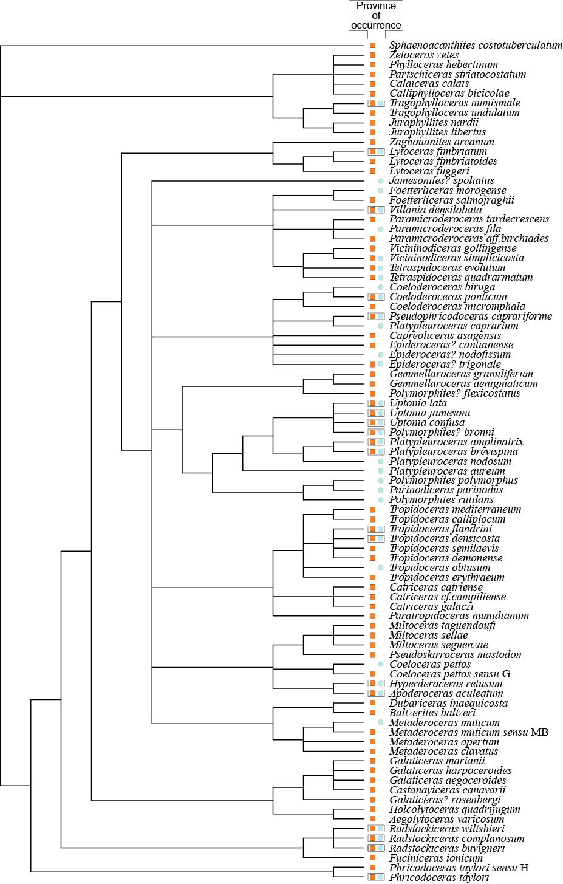

Figure S1.1 Species-level phylogenetic tree for ammonites of the western Tethys and adjacent areas (after Hardy et al., 2012) of the Jamesoni chronozone with recalculated branch lengths

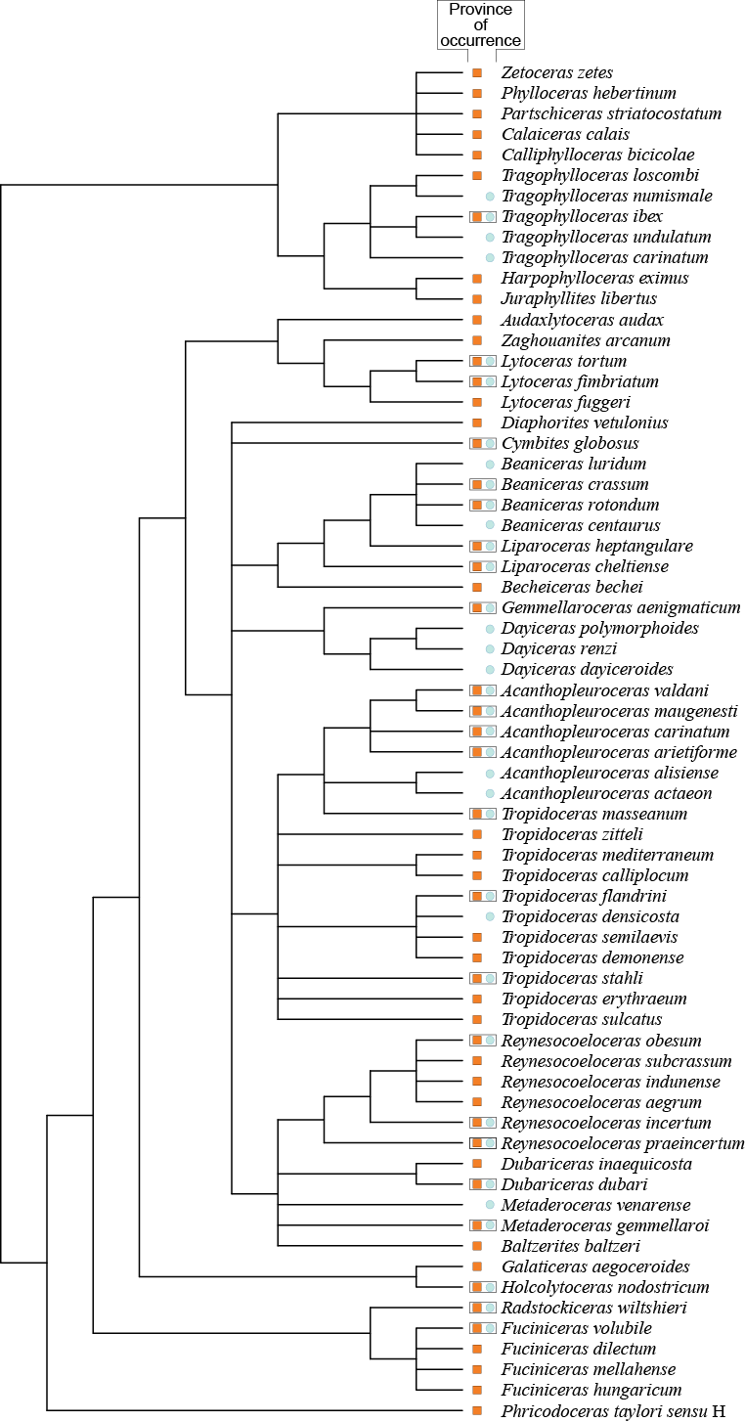
Figure S1.2 Species-level phylogenetic tree for ammonites of the western Tethys and adjacent areas (after Hardy et al., 2012) of the Ibex chronozone with recalculated branch lengths

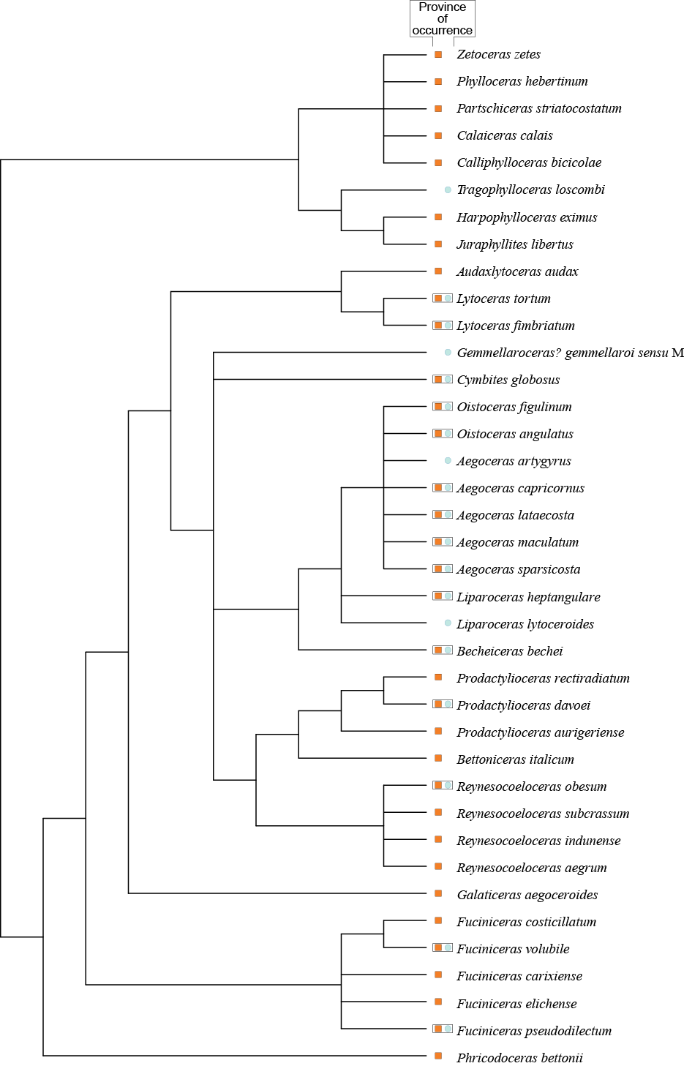
Figure S1.3 Species-level phylogenetic tree for ammonites of the western Tethys and adjacent areas (after Hardy et al., 2012) of the Davoei chronozone with recalculated branch lengths

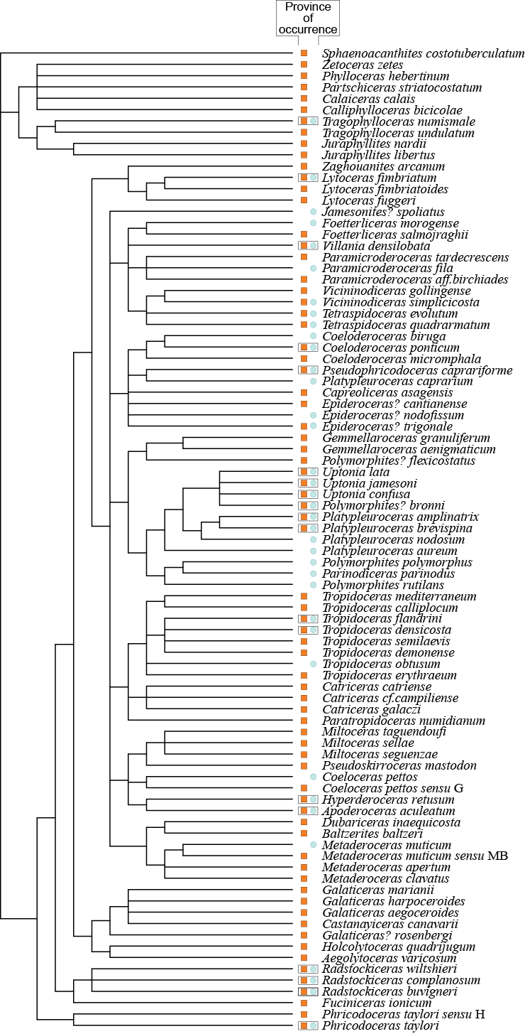

Figure S1.4 Species-level phylogenetic tree for ammonites of the western Tethys and adjacent areas (after Hardy et al., 2012) of the Jamesoni chronozone without recalculated branch lengths

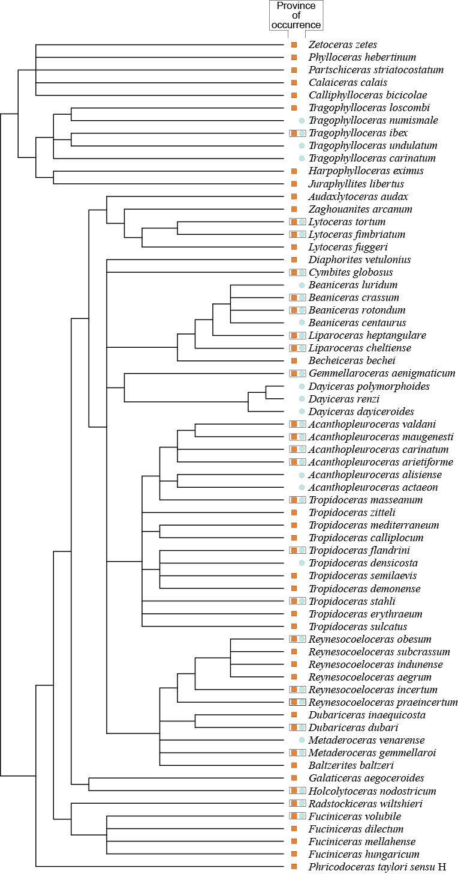
Figure S1.5 Species-level phylogenetic tree for ammonites of the western Tethys and adjacent areas (after Hardy et al., 2012) of the Ibex chronozone without recalculated branch lengths

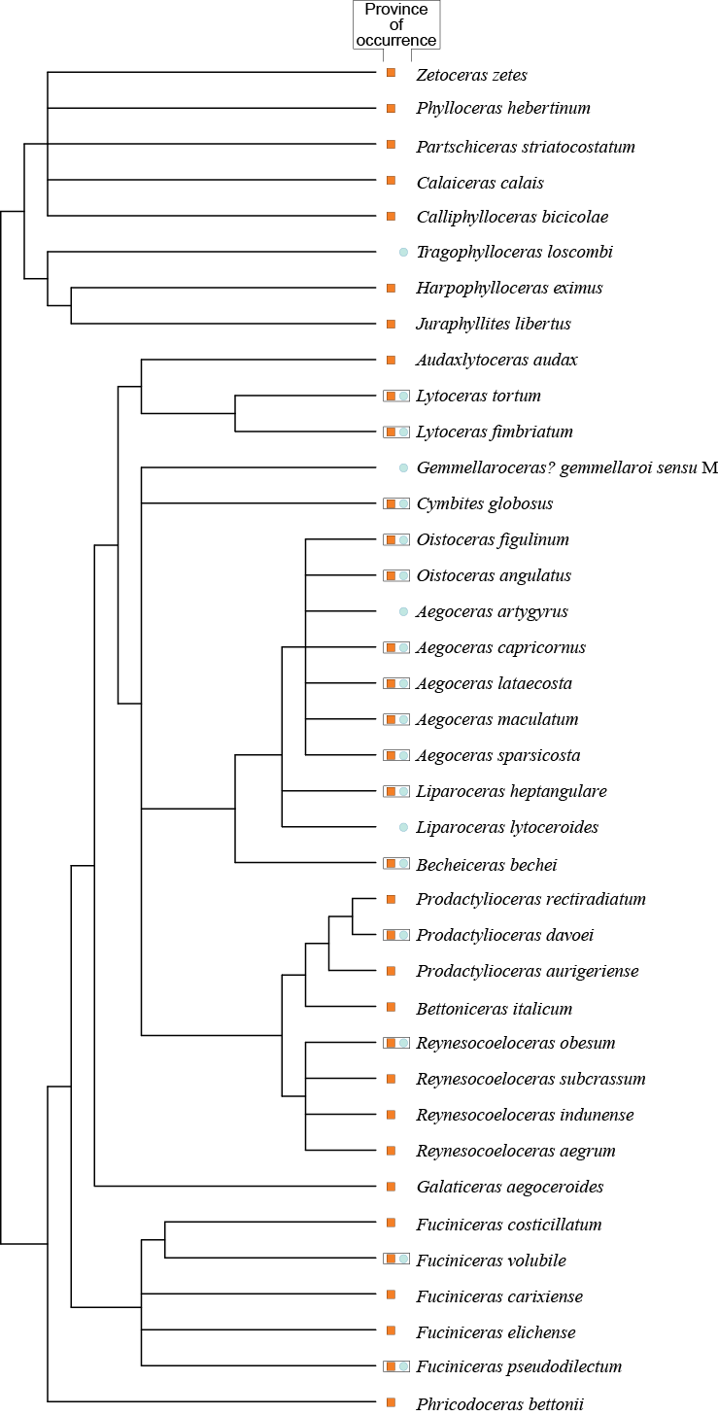
Figure S1.6 Species-level phylogenetic tree for ammonites of the western Tethys and adjacent areas (after Hardy et al., 2012) of the Davoei chronozone without recalculated branch lengths

