APPENDIX S1. SUPPLEMENTARY TABLES AND FIGURES

Table S1.1. All species detected at 490 point count stations in southern Indiana during the breeding seasons of 2011-2013 in taxonomic order. Species which do not breed in the region and species that are poorly sampled with point count methodology were placed in the “Other” habitat group and eliminated from analyses. The remaining species were classified as forest edge specialists (Edge), forest interior specialists (Interior), forest generalists (Forest), or habitat generalists (Non-forest). There were a maximum of 1470 site-year combinations in which each species could be detected. Species detected in 0 site-years were recorded during at least one point count survey, but not close enough (within 50 m) to be considered using the site.
Common name | Scientific name | Habitat group | Detected | % detected
Canada Goose | Branta canadensis | Other | 3 | 0.20
Wood Duck | Aix sponsa | Other | 1 | 0.07
Mallard | Anas platyrhynchos | Other | 0 | 0.00
Northern Bobwhite | Colinus virginianus | Non-forest | 18 | 1.22
Ruffed Grouse | Bonasa umbellus | Other | 1 | 0.07
Wild Turkey | Meleagris gallopavo | Other | 25 | 1.70
Common Loon | Gavia immer | Other | 0 | 0.00
Great Blue Heron | Ardea herodias | Other | 7 | 0.48
Great Egret | Ardea alba | Other | 0 | 0.00
Green Heron | Butorides virescens | Other | 0 | 0.00
Black Vulture | Coragyps atratus | Other | 0 | 0.00
Turkey Vulture | Cathartes aura | Other | 6 | 0.41
Sharp-shinned Hawk | Accipiter striatus | Other | 0 | 0.00
Cooper's Hawk | Accipiter cooperii | Other | 3 | 0.20
Red-shouldered Hawk | Buteo lineatus | Other | 16 | 1.09
Broad-winged Hawk | Buteo platypterus | Other | 2 | 0.14
Red-tailed Hawk | Buteo jamaicensis | Other | 8 | 0.54
American Kestrel | Falco sparverius | Other | 0 | 0.00
American Coot | Fulica americana | Other | 0 | 0.00
Killdeer | Charadrius vociferus | Other | 2 | 0.14
American Woodcock | Scolopax minor | Other | 5 | 0.34
Mourning Dove | Zenaida macroura | Non-forest | 92 | 6.26
Yellow-billed Cuckoo | Coccyzus americanus | Forest | 155 | 10.54
Black-billed Cuckoo | Coccyzus erythropthalmus | Edge | 0 | 0.00
Eastern Screech-Owl | Megascops asio | Other | 2 | 0.14
Great Horned Owl | Bubo virginianus | Other | 1 | 0.07
Barred Owl | Strix varia | Other | 4 | 0.27
Common Nighthawk | Chordeiles minor | Other | 1 | 0.07
Eastern Whip-poor-will | Caprimulgus vociferus | Other | 0 | 0.00
Eastern Whip-poor-will | Caprimulgus vociferus | Non-forest | 4 | 0.27
Chimney Swift | Chaetura pelagica | Other | 9 | 0.61
Ruby-throated Hummingbird | Archilochus colubris | Other | 73 | 4.97
Table S1.1 (continued)
Common name | Scientific name | Habitat group | Detected | % detected
Belted Kingfisher | Megaceryle alcyon | Non-forest | 13 | 0.88
Red-headed Woodpecker | Melanerpes erythrocephalus | Forest | 32 | 2.18
Red-bellied Woodpecker | Melanerpes carolinus | Forest | 638 | 43.40
Downy Woodpecker | Picoides pubescens | Forest | 615 | 41.84
Hairy Woodpecker | Picoides villosus | Forest | 230 | 15.65
Northern Flicker | Colaptes auratus | Edge | 211 | 14.35
Pileated Woodpecker | Dryocopus pileatus | Forest | 139 | 9.46
Eastern Wood-Pewee | Contopus virens | Forest | 771 | 52.45
Acadian Flycatcher | Empidonax virescens | Interior | 1240 | 84.35
Least Flycatcher | Empidonax minimus | Other | 2 | 0.14
Eastern Phoebe | Sayornis phoebe | Edge | 40 | 2.72
Great Crested Flycatcher | Myiarchus crinitus | Edge | 252 | 17.14
Eastern Kingbird | Tyrannus tyrannus | Non-forest | 11 | 0.75
White-eyed Vireo | Vireo griseus | Edge | 365 | 24.83
Yellow-throated Vireo | Vireo flavifrons | Edge | 335 | 22.79
Warbling Vireo | Vireo gilvus | Forest | 16 | 1.09
Red-eyed Vireo | Vireo olivaceus | Forest | 1257 | 85.51
Blue Jay | Cyanocitta cristata | Non-forest | 252 | 17.14
American Crow | Corvus brachyrhynchos | Non-forest | 156 | 10.61
Purple Martin | Progne subis | Other | 1 | 0.07
Tree Swallow | Tachycineta bicolor | Other | 10 | 0.68
Northern Rough-winged Swallow | Stelgidopteryx serripennis | Other | 2 | 0.14
Barn Swallow | Hirundo rustica | Other | 0 | 0.00
Carolina Chickadee | Poecile carolinensis | Forest | 817 | 55.58
Tufted Titmouse | Baeolophus bicolor | Forest | 957 | 65.10
White-breasted Nuthatch | Sitta carolinensis | Forest | 754 | 51.29
Carolina Wren | Thryothorus ludovicianus | Edge | 696 | 47.35
House Wren | Troglodytes aedon | Edge | 9 | 0.61
Blue-gray Gnatcatcher | Polioptila caerulea | Forest | 1029 | 70.00
Eastern Bluebird | Sialia sialis | Non-forest | 38 | 2.59
Veery | Catharus fuscescens | Other | 1 | 0.07
Swainson's Thrush | Catharus ustulatus | Other | 1 | 0.07
Wood Thrush | Hylocichla mustelina | Interior | 660 | 44.90
American Robin | Turdus migratorius | Non-forest | 289 | 19.66
Gray Catbird | Dumetella carolinensis | Edge | 205 | 13.95
Northern Mockingbird | Mimus polyglottos | Non-forest | 4 | 0.27
Brown Thrasher | Toxostoma rufum | Edge | 49 | 3.33
European Starling | Sturnus vulgaris | Non-forest | 2 | 0.14
Cedar Waxwing | Bombycilla cedrorum | Non-forest | 36 | 2.45
Ovenbird | Seiurus aurocapilla | Interior | 258 | 17.55
Worm-eating Warbler | Helmitheros vermivorum | Interior | 80 | 5.44
Louisiana Waterthrush | Parkesia motacilla | Interior | 91 | 6.19
Golden-winged Warbler | Vermivora chrysoptera | Other | 0 | 0.00
Blue-winged Warbler | Vermivora cyanoptera | Edge | 37 | 2.52
Black-and-white Warbler | Mniotilta varia | Forest | 24 | 1.63
Prothonotary Warbler | Protonotaria citrea | Forest | 73 | 4.97
Tennessee Warbler | Oreothlypis peregrina | Other | 0 | 0.00
Nashville Warbler | Oreothlypis ruficapilla | Other | 1 | 0.07
Kentucky Warbler | Geothlypis formosa | Interior | 674 | 45.85
Common Yellowthroat | Geothlypis trichas | Edge | 260 | 17.69
Hooded Warbler | Setophaga citrina | Interior | 253 | 17.21
American Redstart | Setophaga ruticilla | Forest | 25 | 1.70
Cerulean Warbler | Setophaga cerulea | Forest | 93 | 6.33
Northern Parula | Setophaga americana | Forest | 484 | 32.93
Blackburnian Warbler | Setophaga fusca | Other | 0 | 0.00
Yellow Warbler | Setophaga petechia | Edge | 5 | 0.34
Blackpoll Warbler | Setophaga striata | Other | 1 | 0.07
Table S1.1 (continued)
Common name | Scientific name | Habitat group | Detected | % detected
Pine Warbler | Setophaga pinus | Forest | 10 | 0.68
Yellow-rumped Warbler | Setophaga coronata | Other | 0 | 0.00
Yellow-throated Warbler | Setophaga dominica | Forest | 193 | 13.13
Prairie Warbler | Setophaga discolor | Non-forest | 52 | 3.54
Black-throated Green Warbler | Setophaga virens | Forest | 1 | 0.07
Yellow-breasted Chat | Icteria virens | Edge | 227 | 15.44
Eastern Towhee | Pipilo erythrophthalmus | Edge | 904 | 61.50
Chipping Sparrow | Spizella passerina | Edge | 38 | 2.59
Field Sparrow | Spizella pusilla | Non-forest | 36 | 2.45
Song Sparrow | Melospiza melodia | Edge | 53 | 3.61
Summer Tanager | Piranga rubra | Forest | 283 | 19.25
Scarlet Tanager | Piranga olivacea | Interior | 516 | 35.10
Northern Cardinal | Cardinalis cardinalis | Non-forest | 1102 | 74.97
Rose-breasted Grosbeak | Pheucticus ludovicianus | Forest | 2 | 0.14
Blue Grosbeak | Passerina caerulea | Edge | 1 | 0.07
Indigo Bunting | Passerina cyanea | Edge | 892 | 60.68
Red-winged Blackbird | Agelaius phoeniceus | Non-forest | 15 | 1.02
Eastern Meadowlark | Sturnella magna | Non-forest | 2 | 0.14
Common Grackle | Quiscalus quiscula | Non-forest | 35 | 2.38
Brown-headed Cowbird | Molothrus ater | Non-forest | 979 | 66.60
Orchard Oriole | Icterus spurius | Edge | 5 | 0.34
Baltimore Oriole | Icterus galbula | Edge | 48 | 3.27
House Finch | Carpodacus mexicanus | Non-forest | 0 | 0.00
American Goldfinch | Spinus tristis | Non-forest | 172 | 11.70
House Sparrow | Passer domesticus | Non-forest | 0 | 0.00

Table S1.2. Pearson’s correlation coefficients for the six explanatory variables measured at 490 point count stations between 2011 and 2013. All variables were included in breeding bird community occupancy models. PC1-3 represent values of local vegetation principal components (see Table S2.1), and forest amount is the proportion of a 2 km radius circle around the point count station dominated by forest.
 | PC1 | PC2 | PC3 | Edge distance | Forest amount | Log(patch size)
PC1 | 1.000 | ------- | ------- | ------- | ------- | -------
PC2 | 0.000 | 1.000 | ------- | ------- | ------- | -------
PC3 | 0.000 | 0.000 | 1.000 | ------- | ------- | -------
Edge distance | -0.106 | -0.080 | -0.036 | 1.000 | ------- | -------
Forest amount | 0.052 | -0.070 | -0.233 | 0.158 | 1.000 | -------
Log(patch size) | -0.063 | -0.052 | -0.109 | 0.622 | 0.218 | 1.000

Table S1.3. Means and 95% credible intervals for the posterior distributions of covariate effects on occupancy probabilities of 52 breeding bird species. Species were separated into habitat groups (forest edge specialists, forest generalists, or forest interior specialists), and rows highlighted in bold represent the estimated mean effect of the covariate on members of the habitat group. Within a habitat group, species are listed from most common (top) to least common (Table S1.1). The 95% credible intervals did not overlap zero for those entries marked with an asterisk.
Species | Intercept (year = 1) | Intercept (year > 1) | Autologistic | PC1 | PC2 | PC3 | Edge distance | Patch size | Forest amount
Edge specialists | -1.05 (-1.98, -0.22)* | -1.95 (-2.77, -1.15)* | 2.78 (2.16, 3.64)* | 0.20 (0.09, 0.30)* | 0.10 (0.02, 0.20)* | 0.05 (-0.05, 0.13) | -0.40 (-0.68, -0.15)* | -0.16 (-0.28, -0.04)* | -0.08 (-0.33, 0.18)
Eastern Towhee | 1.17 (0.88, 1.49)* | -0.41 (-0.79, -0.04)* | 2.51 (1.91, 3.10)* | 0.42 (0.29, 0.57)* | 0.02 (-0.14, 0.15) | 0.05 (-0.06, 0.17) | -0.17 (-0.33, -0.00)* | -0.17 (-0.33, -0.02)* | -0.23 (-0.41, -0.06)*
Indigo Bunting | 1.85 (1.46, 2.28)* | -0.75 (-1.30, -0.25)* | 2.63 (1.96, 3.35)* | 0.33 (0.18, 0.48)* | 0.11 (-0.03, 0.26) | 0.04 (-0.08, 0.16) | -0.53 (-0.72, -0.35)* | -0.16 (-0.31, 0.01) | -0.04 (-0.23, 0.16)
Carolina Wren | 0.05 (-0.27, 0.39) | 0.30 (-0.06, 0.69) | 2.22 (1.33, 3.02)* | 0.26 (0.13, 0.41)* | 0.12 (-0.02, 0.27) | 0.08 (-0.03, 0.25) | -0.36 (-0.55, -0.16)* | -0.14 (-0.29, 0.03) | -0.73 (-0.94, -0.53)*
White-eyed Vireo | -0.95 (-1.23, -0.67)* | -2.13 (-2.48, -1.80)* | 3.05 (2.46, 3.76)* | 0.25 (0.14, 0.37)* | 0.04 (-0.10, 0.16) | 0.08 (-0.04, 0.22) | -0.39 (-0.61, -0.17)* | -0.20 (-0.39, -0.05)* | 0.18 (0.01, 0.35)*
Yellow-throated Vireo | 0.26 (-0.31, 0.93) | -0.33 (-1.09, 0.72) | 3.06 (1.80, 5.33)* | -0.04 (-0.26, 0.20) | 0.06 (-0.13, 0.24) | 0.03 (-0.14, 0.16) | -0.01 (-0.31, 0.29) | -0.14 (-0.32, 0.07) | 0.20 (-0.10, 0.57)
Common Yellowthroat | -1.03 (-1.39, -0.66)* | -2.50 (-2.92, -2.10)* | 2.52 (1.87, 3.16)* | 0.20 (0.08, 0.33)* | 0.14 (0.02, 0.29)* | 0.05 (-0.08, 0.17) | -0.91 (-1.24, -0.59)* | -0.11 (-0.27, 0.08) | -0.12 (-0.31, 0.06)
Great Crested Flycatcher | -0.31 (-0.98, 0.45) | -0.27 (-1.02, 0.77) | 2.26 (0.46, 3.87)* | 0.03 (-0.20, 0.25) | 0.13 (-0.04, 0.33) | 0.06 (-0.07, 0.21) | 0.09 (-0.17, 0.37) | -0.15 (-0.34, 0.06) | -0.59 (-0.91, -0.30)*
Yellow-breasted Chat | -1.04 (-1.41, -0.68)* | -2.57 (-2.97, -2.17)* | 2.46 (1.82, 3.08)* | 0.33 (0.20, 0.47)* | 0.15 (0.02, 0.30)* | 0.04 (-0.09, 0.16) | -0.49 (-0.77, -0.22)* | -0.14 (-0.29, 0.04) | -0.14 (-0.33, 0.05)
Northern Flicker | -0.33 (-1.06, 0.49) | -0.16 (-0.85, 0.75) | 2.21 (-0.11, 3.95) | 0.10 (-0.12, 0.30) | 0.01 (-0.25, 0.18) | 0.04 (-0.13, 0.18) | 0.34 (0.03, 0.66)* | -0.22 (-0.51, -0.04)* | -0.68 (-1.04, -0.37)*
Gray Catbird | -1.23 (-1.59, -0.86)* | -2.68 (-3.12, -2.29)* | 2.71 (2.02, 3.48)* | 0.18 (0.04, 0.31)* | 0.13 (0.00, 0.27)* | 0.05 (-0.09, 0.17) | -0.49 (-0.77, -0.23)* | -0.17 (-0.34, -0.01)* | 0.17 (-0.02, 0.36)
Song Sparrow | -3.17 (-3.96, -2.39)* | -3.66 (-4.52, -2.89)* | 3.65 (2.35, 6.11)* | 0.18 (-0.02, 0.37) | 0.15 (-0.02, 0.37) | 0.02 (-0.17, 0.15) | -1.10 (-1.97, -0.45)* | -0.22 (-0.50, -0.04)* | -0.30 (-0.62, 0.02)
Brown Thrasher | -1.41 (-2.58, -0.07)* | -2.37 (-3.60, -1.04)* | 2.99 (1.55, 5.24)* | 0.25 (0.00, 0.53)* | 0.19 (0.01, 0.48)* | 0.03 (-0.16, 0.16) | -1.02 (-1.81, -0.41)* | -0.14 (-0.33, 0.10) | -0.19 (-0.68, 0.21)
Baltimore Oriole | -1.07 (-2.47, 0.60) | -2.48 (-3.68, -1.14)* | 3.01 (1.58, 5.24)* | 0.20 (-0.05, 0.46) | 0.04 (-0.22, 0.23) | 0.04 (-0.14, 0.17) | -0.75 (-1.39, -0.20)* | -0.21 (-0.49, -0.02)* | -0.20 (-0.74, 0.23)
Eastern Phoebe | -2.88 (-3.77, -1.78)* | -3.41 (-4.22, -2.49)* | 3.44 (2.23, 5.65)* | 0.17 (-0.04, 0.37) | 0.05 (-0.17, 0.22) | 0.04 (-0.11, 0.19) | -0.19 (-0.61, 0.17) | -0.14 (-0.32, 0.09) | 0.28 (-0.06, 0.61)
Chipping Sparrow | -0.20 (-1.92, 1.95) | -2.37 (-3.94, -0.63)* | 2.73 (-0.43, 5.23) | 0.19 (-0.09, 0.48) | 0.15 (-0.04, 0.43) | 0.03 (-0.16, 0.18) | -0.28 (-0.77, 0.18) | -0.10 (-0.29, 0.21) | 0.68 (0.17, 1.31)*
Blue-winged Warbler | -2.23 (-3.28, -1.03)* | -3.41 (-4.36, -2.36)* | 2.68 (1.15, 4.58)* | 0.26 (0.05, 0.48)* | 0.13 (-0.05, 0.34) | 0.05 (-0.12, 0.19) | -0.03 (-0.42, 0.34) | -0.10 (-0.29, 0.18) | 0.72 (0.32, 1.20)*
House Wren | -1.52 (-3.88, 1.18) | -1.41 (-3.65, 1.40) | 3.07 (1.32, 5.72)* | 0.11 (-0.26, 0.43) | 0.14 (-0.08, 0.45) | 0.04 (-0.15, 0.19) | -0.12 (-0.96, 0.72) | -0.14 (-0.37, 0.12) | -0.49 (-1.19, 0.18)
Orchard Oriole | -2.60 (-5.96, 0.31) | -1.85 (-4.07, 0.71) | 2.89 (1.07, 5.36)* | 0.16 (-0.19, 0.48) | 0.11 (-0.13, 0.38) | 0.06 (-0.10, 0.24) | -0.63 (-1.63, 0.18) | -0.17 (-0.44, 0.08) | -0.07 (-0.91, 0.75)
Yellow Warbler | -1.08 (-3.52, 1.78) | -3.14 (-5.40, -0.40)* | 2.66 (0.71, 4.60)* | 0.22 (-0.10, 0.56) | 0.09 (-0.16, 0.35) | 0.05 (-0.13, 0.21) | -0.61 (-1.65, 0.20) | -0.16 (-0.40, 0.09) | -0.21 (-1.09, 0.60)
Blue Grosbeak | -2.19 (-5.94, 1.38) | -2.17 (-5.04, 0.66) | 2.84 (0.89, 5.13)* | 0.18 (-0.17, 0.50) | 0.11 (-0.14, 0.37) | 0.05 (-0.13, 0.21) | -0.46 (-1.48, 0.44) | -0.16 (-0.40, 0.09) | 0.15 (-0.73, 1.15)
Black-billed Cuckoo | -2.22 (-5.74, 1.14) | -3.21 (-6.42, -0.19)* | 2.65 (0.47, 4.85)* | 0.19 (-0.17, 0.54) | 0.10 (-0.14, 0.37) | 0.05 (-0.13, 0.20) | -0.33 (-1.30, 0.62) | -0.15 (-0.40, 0.11) | -0.07 (-1.06, 0.94)

Table S1.3 (continued)
Species | Intercept (year = 1) | Intercept (year > 1) | Autologistic | PC1 | PC2 | PC3 | Edge distance | Patch size | Forest amount
Forest generalists | 0.11 (-1.29, 1.44) | -1.33 (-2.68, 0.08) | 2.93 (1.82, 4.26)* | 0.04 (-0.05, 0.12) | -0.12 (-0.20, -0.03)* | -0.02 (-0.17, 0.13) | 0.06 (-0.04, 0.16) | 0.01 (-0.16, 0.19) | -0.30 (-0.61, 0.00)
Red-eyed Vireo | 2.48 (2.12, 2.88)* | 1.51 (0.99, 2.06)* | 1.24 (0.63, 1.84)* | -0.17 (-0.32, -0.03)* | -0.12 (-0.24, 0.01) | -0.32 (-0.55, -0.11)* | 0.11 (-0.03, 0.32) | 0.30 (0.06, 0.55)* | 0.31 (0.09, 0.54)*
Blue-gray Gnatcatcher | 2.02 (1.66, 2.42)* | 0.47 (0.01, 0.93)* | 1.73 (1.01, 2.49)* | 0.13 (0.00, 0.26)* | -0.12 (-0.25, -0.00)* | 0.15 (-0.05, 0.35) | 0.04 (-0.12, 0.16) | -0.22 (-0.43, -0.02)* | -0.35 (-0.57, -0.14)*
Tufted Titmouse | 2.52 (1.95, 3.22)* | 2.24 (1.27, 3.50)* | 0.37 (-0.89, 1.52) | 0.05 (-0.12, 0.23) | -0.11 (-0.26, 0.04) | 0.23 (-0.07, 0.53) | 0.04 (-0.12, 0.17) | -0.13 (-0.41, 0.14) | -1.01 (-1.44, -0.64)*
Carolina Chickadee | 3.33 (2.28, 4.90)* | 1.79 (0.59, 3.14)* | 1.10 (-0.62, 3.05) | 0.10 (-0.08, 0.31) | -0.13 (-0.29, 0.02) | 0.10 (-0.23, 0.44) | 0.03 (-0.18, 0.18) | -0.02 (-0.35, 0.31) | -1.17 (-1.73, -0.72)*
Eastern Wood-Pewee | 1.07 (0.70, 1.47)* | -0.49 (-0.96, -0.07)* | 2.70 (1.96, 3.56)* | -0.03 (-0.15, 0.09) | -0.15 (-0.29, -0.02)* | -0.25 (-0.48, -0.04)* | 0.09 (-0.04, 0.24) | -0.03 (-0.23, 0.17) | -0.22 (-0.42, -0.03)*
White-breasted Nuthatch | 1.04 (0.60, 1.53)* | 1.04 (0.38, 1.78)* | 1.87 (0.65, 3.51)* | -0.10 (-0.27, 0.07) | -0.16 (-0.32, -0.03)* | -0.17 (-0.44, 0.09) | 0.08 (-0.06, 0.25) | 0.16 (-0.10, 0.43) | -0.61 (-0.89, -0.33)*
Red-bellied Woodpecker | 0.75 (0.28, 1.30)* | 0.53 (-0.11, 1.20) | 1.05 (0.13, 2.14)* | 0.03 (-0.12, 0.17) | -0.13 (-0.27, -0.01)* | 0.02 (-0.20, 0.25) | 0.08 (-0.05, 0.23) | 0.18 (-0.05, 0.40) | -0.80 (-1.06, -0.55)*
Downy Woodpecker | 1.84 (1.05, 2.96)* | 0.28 (-1.67, 1.93) | 2.20 (-0.12, 5.31) | 0.10 (-0.08, 0.29) | -0.11 (-0.27, 0.04) | -0.11 (-0.43, 0.20) | 0.03 (-0.17, 0.18) | 0.04 (-0.26, 0.34) | -0.41 (-0.76, -0.08)*
Northern Parula | 0.28 (-0.05, 0.62) | -1.80 (-2.37, -1.32)* | 3.15 (2.35, 4.10)* | 0.11 (-0.01, 0.23) | -0.03 (-0.16, 0.14) | -0.01 (-0.19, 0.17) | 0.08 (-0.04, 0.23) | -0.13 (-0.32, 0.06) | -0.07 (-0.26, 0.11)
Summer Tanager | 1.23 (0.54, 2.08)* | -2.52 (-5.15, -0.42)* | 5.92 (2.49, 10.28)* | 0.02 (-0.17, 0.21) | -0.14 (-0.32, -0.00)* | -0.29 (-0.66, 0.05) | 0.05 (-0.12, 0.20) | -0.03 (-0.35, 0.29) | -0.50 (-0.99, -0.09)*
Hairy Woodpecker | -1.96 (-2.66, -1.27)* | 1.35 (0.44, 2.81)* | 1.25 (-1.14, 5.88) | 0.10 (-0.08, 0.32) | -0.15 (-0.34, -0.01)* | 0.11 (-0.24, 0.49) | 0.06 (-0.11, 0.24) | 0.35 (-0.02, 0.77) | -0.41 (-0.83, -0.01)*
Yellow-throated Warbler | -0.16 (-0.70, 0.44) | -2.78 (-4.28, -1.89)* | 3.36 (1.83, 5.63)* | 0.03 (-0.11, 0.17) | -0.08 (-0.21, 0.07) | -0.04 (-0.30, 0.21) | 0.07 (-0.08, 0.21) | -0.17 (-0.41, 0.07) | -0.02 (-0.25, 0.20)
Yellow-billed Cuckoo | 4.02 (1.90, 7.77)* | -4.56 (-7.15, -2.67)* | 4.19 (2.22, 6.85)* | 0.07 (-0.11, 0.26) | -0.09 (-0.24, 0.09) | 0.17 (-0.15, 0.53) | 0.09 (-0.06, 0.28) | 0.46 (0.08, 0.87)* | -0.80 (-1.24, -0.40)*
Pileated Woodpecker | 4.01 (1.59, 7.99)* | 1.25 (-2.95, 6.47) | 3.62 (-0.44, 8.38) | 0.03 (-0.22, 0.28) | -0.12 (-0.32, 0.07) | -0.02 (-0.53, 0.50) | 0.08 (-0.11, 0.28) | 0.03 (-0.51, 0.59) | -0.47 (-1.62, 0.56)
Cerulean Warbler | -1.94 (-2.43, -1.44)* | -3.99 (-5.32, -3.11)* | 5.24 (3.32, 8.23)* | 0.04 (-0.13, 0.20) | -0.13 (-0.29, 0.01) | -0.24 (-0.53, 0.04) | 0.07 (-0.08, 0.23) | -0.09 (-0.37, 0.17) | 0.56 (0.26, 0.87)*
Prothonotary Warbler | -2.88 (-3.53, -2.25)* | -4.53 (-5.69, -3.70)* | 4.11 (2.45, 6.50)* | 0.01 (-0.16, 0.19) | -0.10 (-0.25, 0.06) | 0.14 (-0.15, 0.45) | 0.05 (-0.14, 0.22) | -0.23 (-0.60, 0.10) | -1.04 (-1.43, -0.68)*
Red-headed Woodpecker | -1.36 (-2.79, 0.62) | -3.46 (-5.15, -1.90)* | 2.45 (0.17, 5.11)* | 0.05 (-0.15, 0.27) | -0.10 (-0.26, 0.09) | -0.05 (-0.42, 0.30) | 0.05 (-0.16, 0.21) | 0.02 (-0.39, 0.42) | -0.82 (-1.32, -0.38)*
American Redstart | -0.51 (-3.36, 4.62) | -1.23 (-4.30, 4.93) | 3.91 (-0.15, 8.39) | 0.05 (-0.18, 0.30) | -0.10 (-0.27, 0.10) | 0.12 (-0.34, 0.63) | 0.06 (-0.14, 0.23) | 0.08 (-0.38, 0.56) | 0.15 (-0.75, 0.88)
Black-and-white Warbler | -3.30 (-4.68, -1.80)* | -3.84 (-5.24, -2.39)* | 4.19 (1.42, 8.37)* | 0.10 (-0.10, 0.34) | -0.11 (-0.27, 0.07) | -0.21 (-0.61, 0.15) | 0.04 (-0.20, 0.19) | -0.22 (-0.62, 0.15) | 0.78 (0.28, 1.32)*
Warbling Vireo | -3.77 (-4.68, -2.80)* | -5.90 (-7.84, -4.45)* | 5.16 (2.58, 7.98)* | 0.03 (-0.18, 0.25) | -0.13 (-0.31, 0.03) | 0.10 (-0.26, 0.51) | 0.03 (-0.24, 0.18) | -0.37 (-0.89, 0.06) | -0.24 (-0.73, 0.22)
Pine Warbler | 0.17 (-3.50, 4.95) | -1.12 (-4.65, 4.13) | 2.56 (-2.39, 7.65) | 0.04 (-0.22, 0.29) | -0.12 (-0.30, 0.07) | 0.06 (-0.43, 0.60) | 0.06 (-0.15, 0.25) | 0.07 (-0.44, 0.61) | 0.29 (-0.92, 1.33)
Rose-breasted Grosbeak | -3.27 (-8.42, 2.28) | -1.71 (-5.92, 3.74) | 3.21 (-1.18, 7.88) | 0.05 (-0.21, 0.32) | -0.11 (-0.30, 0.08) | -0.01 (-0.52, 0.52) | 0.06 (-0.14, 0.25) | 0.02 (-0.54, 0.60) | -0.25 (-1.44, 0.84)
Black-throated Green Warbler | -2.95 (-8.78, 2.81) | -2.96 (-7.35, 3.32) | 2.93 (-1.42, 7.49) | 0.01 (-0.26, 0.27) | -0.11 (-0.30, 0.07) | -0.03 (-0.53, 0.49) | 0.07 (-0.12, 0.25) | 0.11 (-0.44, 0.70) | 0.09 (-1.05, 1.36)
Interior specialists | -0.25 (-1.78, 1.27) | -1.85 (-3.58, -0.17)* | 3.73 (2.31, 5.38)* | -0.02 (-0.36, 0.30) | -0.17 (-0.34, 0.01) | -0.12 (-0.30, 0.03) | 0.28 (0.05, 0.51)* | 0.46 (0.23, 0.69)* | 0.38 (-0.16, 0.93)
Acadian Flycatcher | 1.88 (1.57, 2.22)* | 0.21 (-0.22, 0.63) | 3.45 (2.86, 4.08)* | -0.27 (-0.40, -0.13)* | -0.23 (-0.39, -0.08)* | -0.07 (-0.25, 0.11) | 0.26 (0.01, 0.51)* | 0.35 (0.11, 0.58)* | -0.13 (-0.34, 0.08)
Kentucky Warbler | 1.62 (1.13, 2.17)* | -1.78 (-3.11, -0.86)* | 4.54 (3.22, 6.38)* | 0.48 (0.27, 0.71)* | -0.22 (-0.45, -0.02)* | -0.06 (-0.26, 0.20) | 0.25 (-0.02, 0.54) | 0.42 (0.14, 0.68)* | 0.05 (-0.21, 0.32)
Wood Thrush | 0.49 (0.14, 0.83)* | -0.97 (-1.39, -0.58)* | 2.58 (1.93, 3.30)* | 0.12 (-0.01, 0.26) | -0.21 (-0.37, -0.06)* | -0.03 (-0.20, 0.16) | 0.24 (0.03, 0.44)* | 0.40 (0.18, 0.60)* | -0.04 (-0.22, 0.14)
Scarlet Tanager | 0.81 (0.33, 1.34)* | -0.20 (-0.82, 0.41) | 1.49 (0.41, 2.70)* | -0.03 (-0.20, 0.15) | 0.03 (-0.18, 0.27) | -0.22 (-0.48, -0.01)* | 0.26 (-0.01, 0.52) | 0.54 (0.31, 0.82)* | 0.57 (0.34, 0.82)*
Ovenbird | -1.47 (-1.89, -1.06)* | -3.12 (-3.80, -2.54)* | 4.18 (3.11, 5.42)* | -0.20 (-0.39, -0.01)* | -0.03 (-0.23, 0.22) | -0.17 (-0.41, 0.04) | 0.53 (0.21, 0.93)* | 0.71 (0.40, 1.07)* | 1.02 (0.72, 1.33)*
Hooded Warbler | -1.61 (-2.00, -1.20)* | -3.95 (-4.86, -3.27)* | 4.46 (3.36, 5.75)* | 0.37 (0.19, 0.55)* | -0.23 (-0.45, -0.03)* | -0.20 (-0.46, 0.01) | 0.41 (0.17, 0.72)* | 0.56 (0.32, 0.81)* | 1.12 (0.83, 1.45)*
Louisiana Waterthrush | -1.27 (-2.30, -0.01)* | -0.68 (-1.78, 0.69) | 5.30 (2.80, 8.94)* | -0.25 (-0.60, 0.08) | -0.22 (-0.55, 0.04) | -0.14 (-0.47, 0.15) | 0.21 (-0.16, 0.56) | 0.30 (-0.15, 0.68) | -0.23 (-0.81, 0.33)
Worm-eating Warbler | -2.30 (-2.91, -1.67)* | -4.36 (-5.71, -3.42)* | 3.88 (1.89, 6.56)* | -0.41 (-0.70, -0.13)* | -0.22 (-0.49, 0.00) | -0.10 (-0.36, 0.15) | 0.08 (-0.23, 0.36) | 0.45 (0.14, 0.75)* | 0.71 (0.36, 1.09)*

Table S1.4. Means and 95% credible intervals for the posterior distributions of covariate effects on detection probabilities of 52 breeding bird species. Species were separated into habitat groups (forest edge specialists, forest generalists, or forest interior specialists), but we did not expect detection covariates to vary systematically among habitat groups. Therefore, a single mean effect of each covariate was estimated for the entire bird community. The 95% credible intervals did not overlap zero for those entries marked with an asterisk.
Species | Intercept | Julian date | Tree basal area
Entire community | -2.16 (-2.76, -1.60)* | -0.16 (-0.26, -0.06)* | 0.02 (-0.02, 0.06)
Edge specialists | -- | -- | --
Eastern Towhee | -0.08 (-0.16, 0.01) | 0.10 (0.03, 0.17)* | -0.11 (-0.19, -0.04)*
Indigo Bunting | -0.29 (-0.37, -0.20)* | 0.02 (-0.04, 0.09) | -0.02 (-0.10, 0.06)
Carolina Wren | -0.68 (-0.78, -0.58)* | 0.18 (0.10, 0.26)* | 0.11 (0.03, 0.19)*
White-eyed Vireo | -0.38 (-0.53, -0.22)* | -0.02 (-0.12, 0.09) | -0.16 (-0.28, -0.05)*
Yellow-throated Vireo | -1.87 (-2.10, -1.63)* | -0.01 (-0.11, 0.10) | -0.02 (-0.13, 0.09)
Common Yellowthroat | -1.00 (-1.21, -0.79)* | 0.29 (0.16, 0.42)* | -0.09 (-0.22, 0.03)
Great Crested Flycatcher | -2.08 (-2.38, -1.76)* | -0.33 (-0.45, -0.20)* | 0.20 (0.07, 0.33)*
Yellow-breasted Chat | -1.01 (-1.22, -0.79)* | 0.08 (-0.05, 0.22) | -0.02 (-0.15, 0.10)
Northern Flicker | -2.28 (-2.57, -1.91)* | 0.25 (0.11, 0.38)* | 0.06 (-0.07, 0.18)
Gray Catbird | -0.95 (-1.20, -0.71)* | -0.11 (-0.25, 0.03) | -0.08 (-0.23, 0.06)
Song Sparrow | -1.84 (-2.43, -1.31)* | -0.01 (-0.26, 0.24) | 0.02 (-0.16, 0.21)
Brown Thrasher | -3.25 (-3.96, -2.42)* | -0.48 (-0.76, -0.21)* | -0.07 (-0.27, 0.10)
Baltimore Oriole | -3.34 (-4.13, -2.36)* | -0.65 (-0.96, -0.36)* | 0.02 (-0.16, 0.19)
Eastern Phoebe | -2.02 (-2.99, -1.22)* | -0.60 (-0.92, -0.29)* | 0.01 (-0.18, 0.20)
Chipping Sparrow | -3.85 (-4.66, -2.89)* | -0.67 (-1.00, -0.36)* | -0.01 (-0.19, 0.16)
Blue-winged Warbler | -2.71 (-3.64, -1.77)* | -0.78 (-1.15, -0.45)* | -0.07 (-0.27, 0.11)
House Wren | -5.13 (-6.34, -3.55)* | -0.50 (-0.99, -0.05)* | 0.03 (-0.16, 0.23)
Orchard Oriole | -5.23 (-6.68, -3.29)* | -0.26 (-0.77, 0.25) | 0.02 (-0.17, 0.22)
Yellow Warbler | -5.15 (-6.64, -3.26)* | -0.19 (-0.70, 0.31) | 0.02 (-0.19, 0.22)
Blue Grosbeak | -6.29 (-8.37, -3.89)* | -0.05 (-0.64, 0.55) | 0.01 (-0.19, 0.21)
Black-billed Cuckoo | -6.58 (-9.28, -3.87)* | -0.15 (-0.75, 0.45) | 0.02 (-0.19, 0.22)

Table S1.4 (continued)
Species | Intercept | Julian date | Tree basal area
Forest generalists | -- | -- | --
Red-eyed Vireo | 0.76 (0.68, 0.83)* | 0.02 (-0.04, 0.09) | 0.08 (0.00, 0.15)*
Blue-gray Gnatcatcher | -0.14 (-0.23, -0.05)* | -0.51 (-0.58, -0.44)* | 0.03 (-0.04, 0.10)
Tufted Titmouse | -0.52 (-0.61, -0.44)* | -0.05 (-0.11, 0.02) | -0.00 (-0.07, 0.07)
Carolina Chickadee | -0.99 (-1.08, -0.89)* | -0.02 (-0.09, 0.05) | -0.00 (-0.07, 0.07)
Eastern Wood-Pewee | -0.54 (-0.64, -0.44)* | 0.11 (0.04, 0.18)* | 0.05 (-0.04, 0.13)
White-breasted Nuthatch | -0.93 (-1.04, -0.81)* | 0.18 (0.11, 0.25)* | 0.04 (-0.04, 0.12)
Red-bellied Woodpecker | -0.92 (-1.06, -0.78)* | -0.14 (-0.22, -0.07)* | 0.10 (0.01, 0.19)*
Downy Woodpecker | -1.32 (-1.45, -1.17)* | 0.04 (-0.04, 0.12) | 0.06 (-0.02, 0.15)
Northern Parula | -0.87 (-1.00, -0.72)* | -0.17 (-0.27, -0.08)* | 0.05 (-0.05, 0.15)
Summer Tanager | -2.15 (-2.35, -1.94)* | -0.01 (-0.13, 0.10) | 0.02 (-0.09, 0.13)
Hairy Woodpecker | -2.20 (-2.46, -1.91)* | 0.06 (-0.07, 0.19) | 0.01 (-0.11, 0.12)
Yellow-throated Warbler | -1.76 (-2.07, -1.44)* | -0.15 (-0.29, -0.01)* | 0.03 (-0.11, 0.17)
Yellow-billed Cuckoo | -2.54 (-2.76, -2.31)* | 0.17 (0.02, 0.33)* | 0.02 (-0.11, 0.15)
Pileated Woodpecker | -3.32 (-3.51, -3.10)* | -0.20 (-0.36, -0.04)* | 0.06 (-0.06, 0.20)
Cerulean Warbler | -1.82 (-2.20, -1.44)* | -0.58 (-0.81, -0.37)* | -0.04 (-0.21, 0.13)
Prothonotary Warbler | -1.38 (-1.80, -0.95)* | -0.30 (-0.52, -0.07)* | 0.04 (-0.12, 0.20)
Red-headed Woodpecker | -3.05 (-3.98, -2.13)* | -0.13 (-0.44, 0.18) | 0.07 (-0.11, 0.25)
American Redstart | -4.26 (-5.40, -2.64)* | -0.49 (-0.86, -0.14)* | -0.04 (-0.24, 0.13)
Black-and-white Warbler | -2.63 (-3.76, -1.55)* | -0.50 (-0.88, -0.14)* | -0.03 (-0.23, 0.16)
Warbling Vireo | -1.53 (-2.53, -0.67)* | 0.13 (-0.26, 0.54) | 0.11 (-0.08, 0.33)
Pine Warbler | -5.12 (-6.40, -2.93)* | -0.08 (-0.53, 0.36) | 0.06 (-0.13, 0.26)
Rose-breasted Grosbeak | -5.66 (-8.00, -2.25)* | -0.33 (-0.92, 0.23) | -0.00 (-0.20, 0.20)
Black-throated Green Warbler | -5.69 (-8.39, -2.12)* | -0.08 (-0.66, 0.48) | 0.02 (-0.18, 0.21)
Interior specialists | -- | -- | --
Acadian Flycatcher | 1.36 (1.27, 1.44)* | -0.13 (-0.21, -0.05)* | 0.04 (-0.04, 0.11)
Kentucky Warbler | -0.95 (-1.06, -0.84)* | -0.01 (-0.09, 0.07) | -0.07 (-0.16, 0.01)
Wood Thrush | -0.48 (-0.60, -0.36)* | 0.24 (0.16, 0.33)* | 0.14 (0.04, 0.23)*
Scarlet Tanager | -1.12 (-1.27, -0.98)* | 0.10 (0.01, 0.19)* | 0.09 (-0.02, 0.19)
Ovenbird | -1.10 (-1.27, -0.92)* | -0.64 (-0.78, -0.50)* | 0.10 (-0.02, 0.23)
Hooded Warbler | -0.67 (-0.86, -0.48)* | -0.09 (-0.21, 0.03) | -0.06 (-0.19, 0.07)
Louisiana Waterthrush | -3.12 (-3.58, -2.60)* | -0.55 (-0.77, -0.35)* | -0.04 (-0.20, 0.11)
Worm-eating Warbler | -1.76 (-2.21, -1.31)* | -0.43 (-0.65, -0.21)* | 0.05 (-0.12, 0.22)

Table S1.5. Pearson’s correlation between patch size and % forest cover variables used in our models, and % forest cover measured at alternative spatial scales around 490 point count stations. The scale presented for each forest cover metric defines the radius of a circle centered on the point count station. When we measured % forest cover at scales between 750 m and 5 km, these values were highly correlated with % forest cover at a 2 km scale. When we measured it at finer spatial scales, correlation with patch size increased dramatically. Thus, we chose not to use these alternative metrics in our models.
 |  | Alternative scales for measuring % forest cover
Variables used |  | 250 m | 500 m | 750 m | 1 km | 1.5 km | 3 km | 4 km | 5 km
Patch size |  | 0.58 | 0.53 | 0.45 | 0.38 | 0.28 | 0.17 | 0.16 | 0.16
% Forest 2 km |  | 0.36 | 0.65 | 0.81 | 0.89 | 0.98 | 0.97 | 0.94 | 0.91

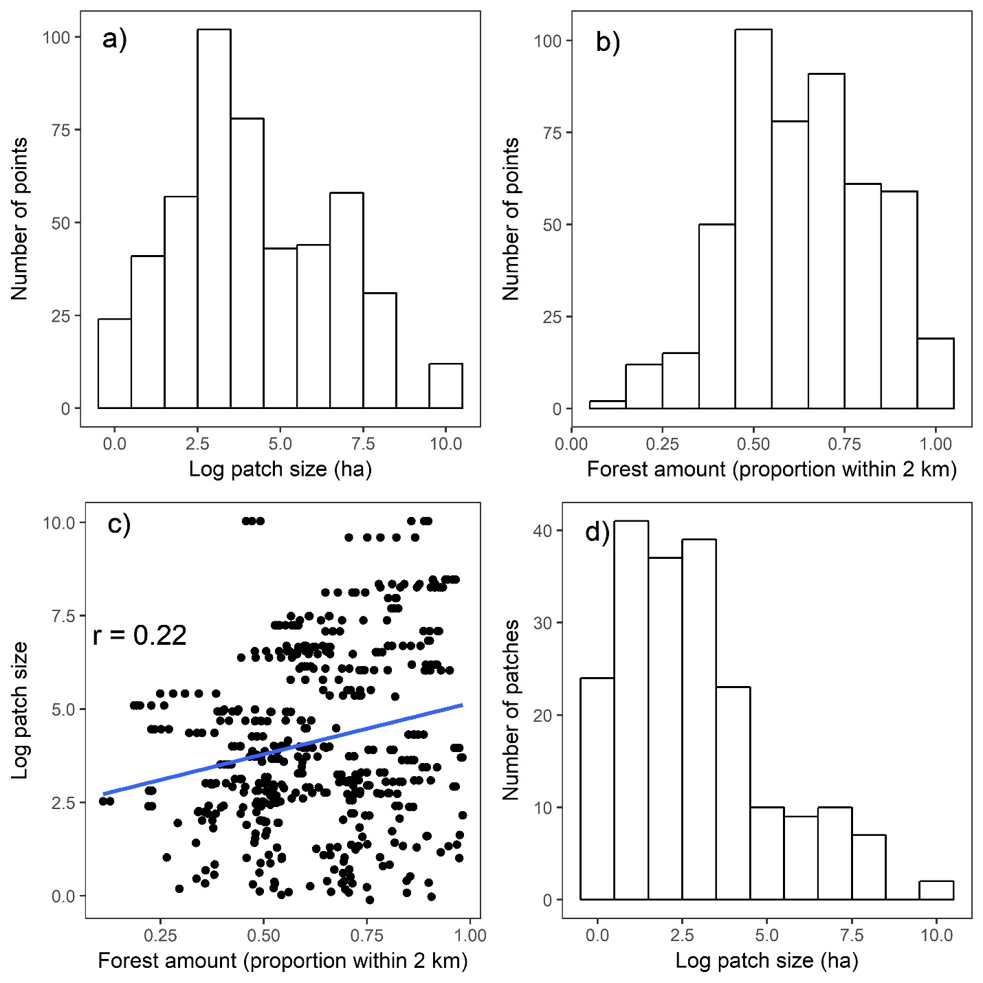
Figure S1.1. A representation of the distribution of landscape covariates in our stratified-random sample of point count locations. The histograms in a) and b) show the frequency of patch size and habitat amount values (respectively) measured at the point scale (n = 490), and the sampling scheme was designed to minimize correlation between these covariates (c). Many patches had multiple points in them, and d) depicts the distribution in size for the 202 unique patches sampled.
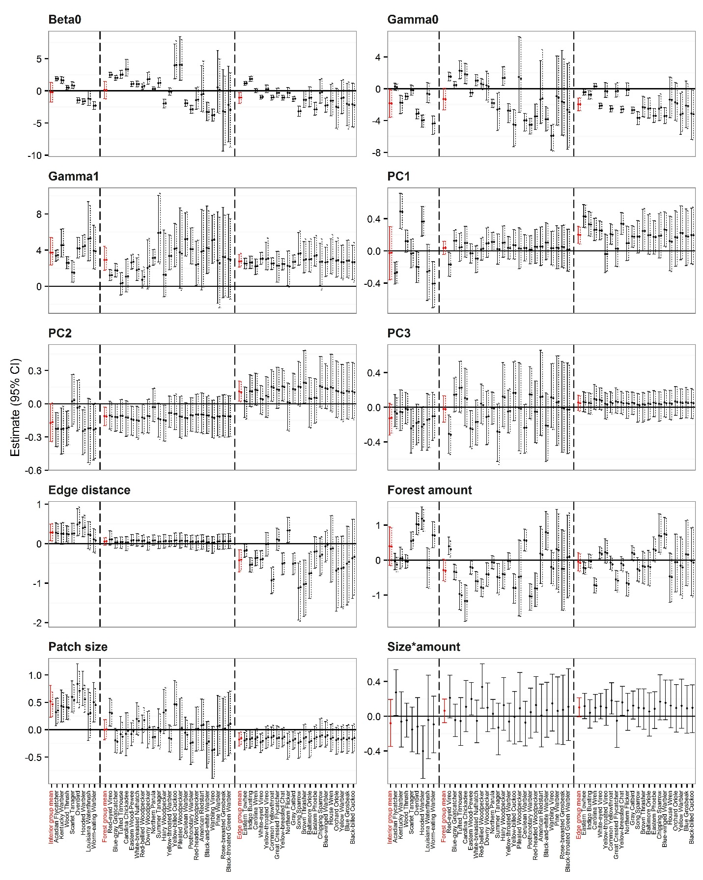
Figure S1.2. A comparison of the posterior means and credible intervals of the parameter estimates from a community occupancy model that did (solid lines) and did not (dashed lines) include an interaction term between patch size and forest amount. In every case, the parameter estimates were nearly identical between the two models.

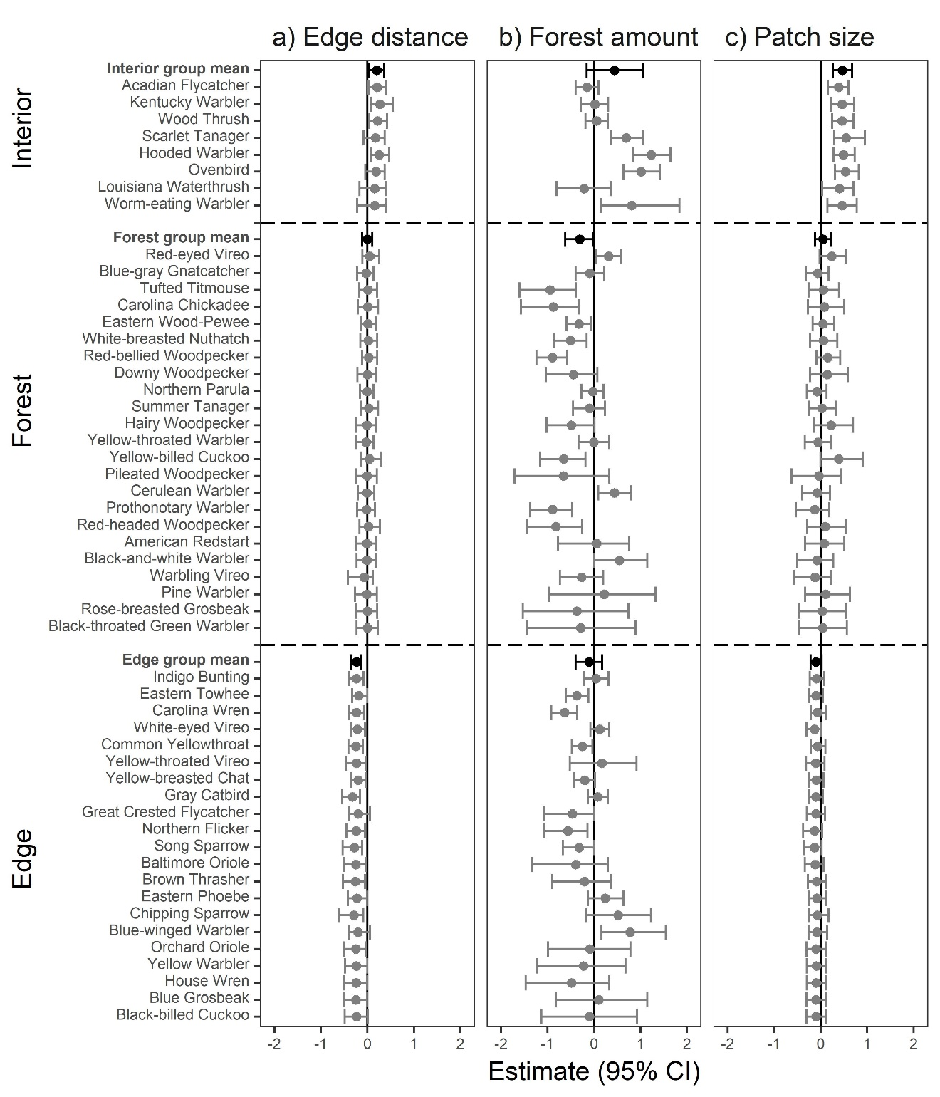
Figure S1.3. To ensure that observed patch size effects were not merely a function of correlation between patch size and edge distance, we re-analyzed the data using only point count stations located within 100 m of a forest edge. This figure shows the results from that model: the posterior means and 95% credible intervals for the effects of a) edge distance, b) amount of forest within 2 km, and c) log-transformed patch size on probability of occupancy for breeding forest bird communities. Species were divided into three ecological trait groups (interior specialist, forest generalist, or edge specialist), and the mean effect of the covariate on members of each group was estimated along with individual effects. Within each trait group, species are listed from most common (top) to least common, or equivalently, from most influential on the group mean estimate, to least. Note that all covariates were standardized with a mean of 0 and standard deviation of 1 prior to model fitting.

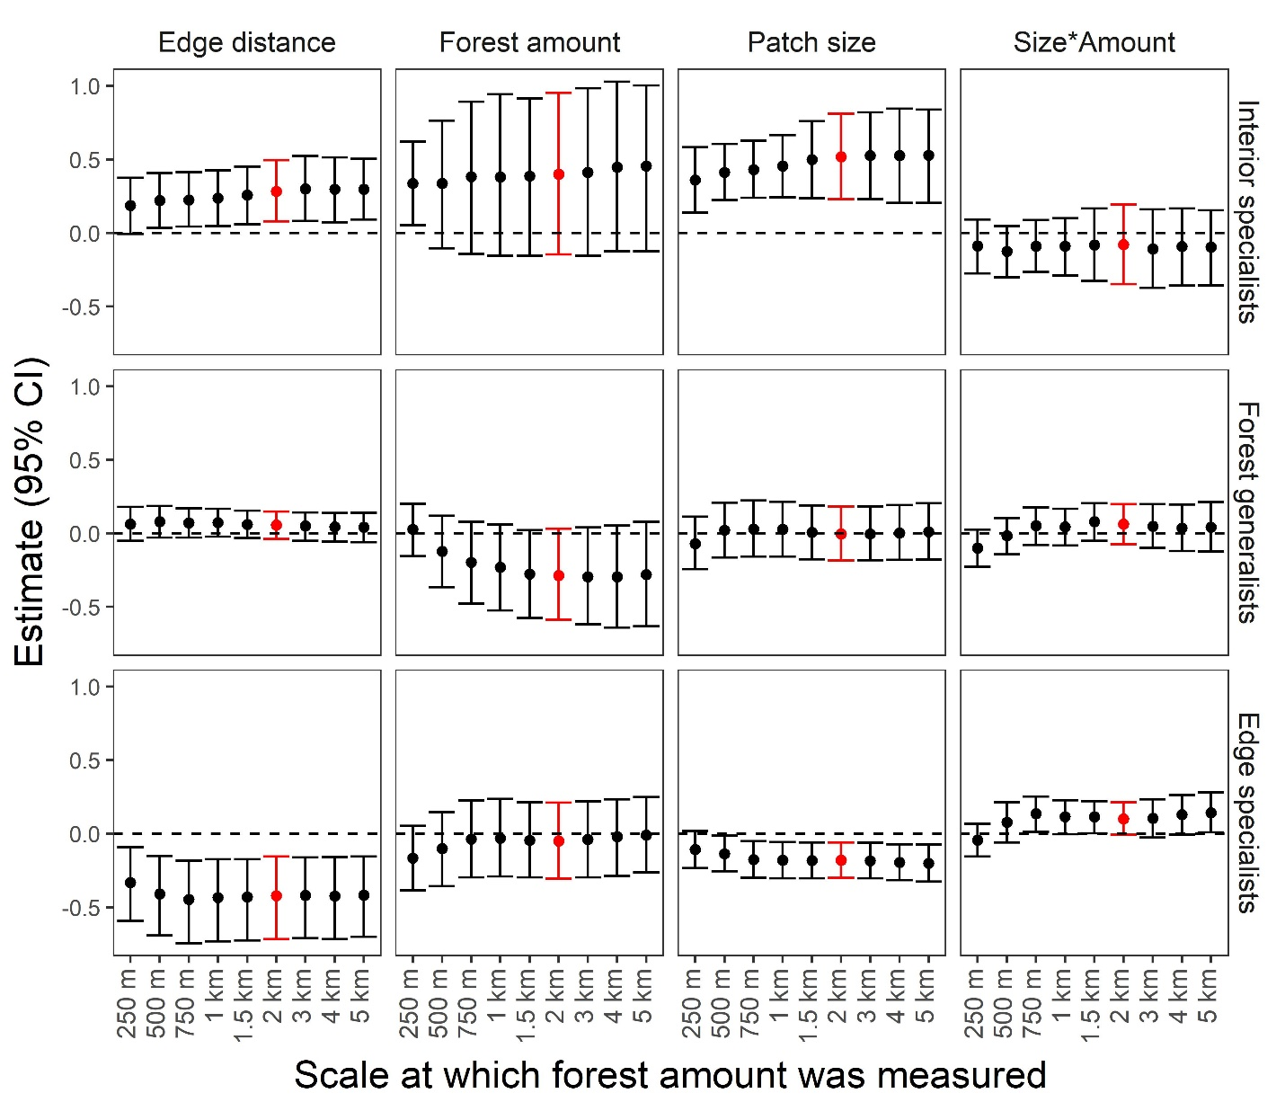
Figure S1.4. In addition to the models presented in the manuscript, we fit models where the forest amount covariate was measured at 8 alternative spatial scales (250 m, 500 m, 750 m, 1 km, 1.5 km, 3 km, 4 km, and 5 km). Here we present the effect of four covariates (edge distance, forest amount, patch size, and a patch-by-amount interaction) from those models on the average member of the three ecological trait groups (interior specialists, forest generalists, and edge specialists). In the model presented in the main body of the manuscript, we measured forest amount at a 2 km spatial scale (highlighted in red). Parameter estimates differed little between 750 m and 5 km due to high correlation among the forest amount covariate measured at these scales (Table S1.5). At finer spatial scales (250 m and 500 m), forest amount was strongly correlated with patch size (Table S1.5) making it difficult to discern the independent effects of these variables on occupancy.

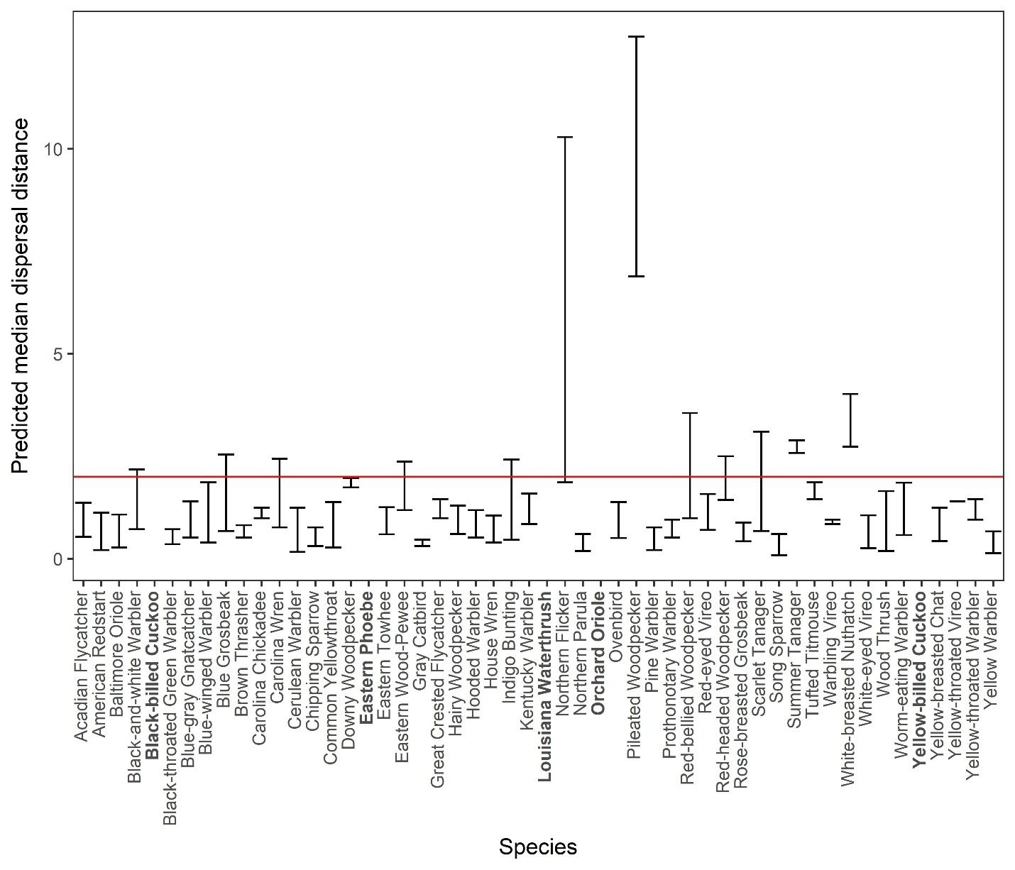

Figure S1.5. The range in predicted median natal dispersal distances for the 52 species (ordered alphabetically) modeled in our study. To generate these values, we converted minimum and maximum reported home range sizes (Rodewald 2015) into dispersal estimates following Bowman (2003). The red horizontal line indicates the 2 km scale at which we measured habitat amount. Median dispersal ranges for 94% of species encompassed or were smaller than 2 km. Therefore, our habitat amount metric likely encompassed ecologically relevant scales for most species. Information on home range size was missing for 5 species (bold).

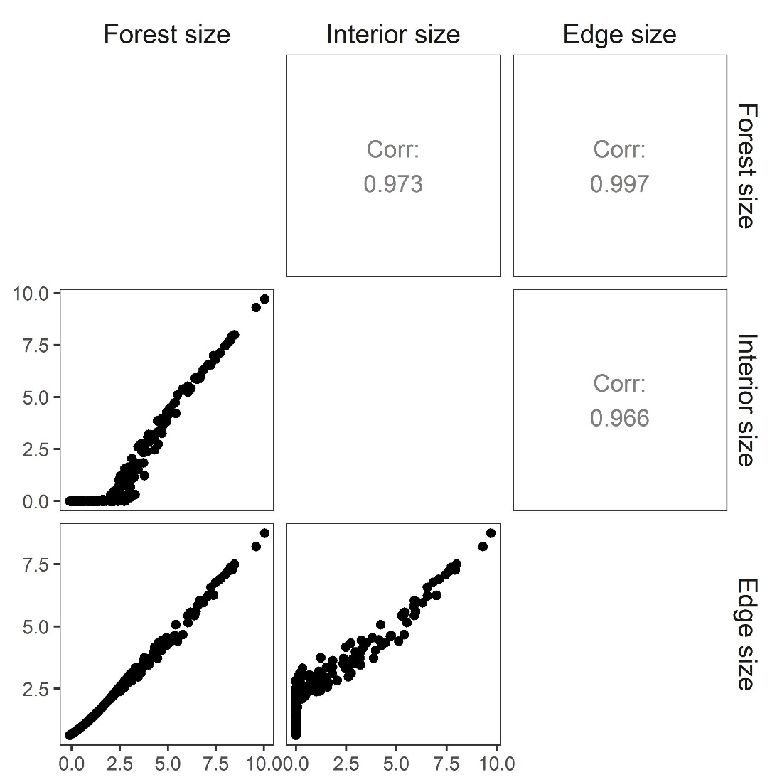
Figure S1.6. Forest patch size may not be a relevant measure of the amount of forest available to interior and edge specialists. Thus, for each of the 202 patches we sampled, we also calculated interior patch size by excluding all parts of the patch within 100 m of a forest edge. Edge patch size is the difference between forest patch size and interior patch size. Here we show the relationship between these metrics for our 490 point count stations. Because all of these measures of patch size are highly correlated, replacing forest patch size with either interior or edge patch size resulted in very similar parameter estimates for patch size effects. Because some interior patch sizes were zero, we transformed all values by adding 1 and then taking the natural logarithm.

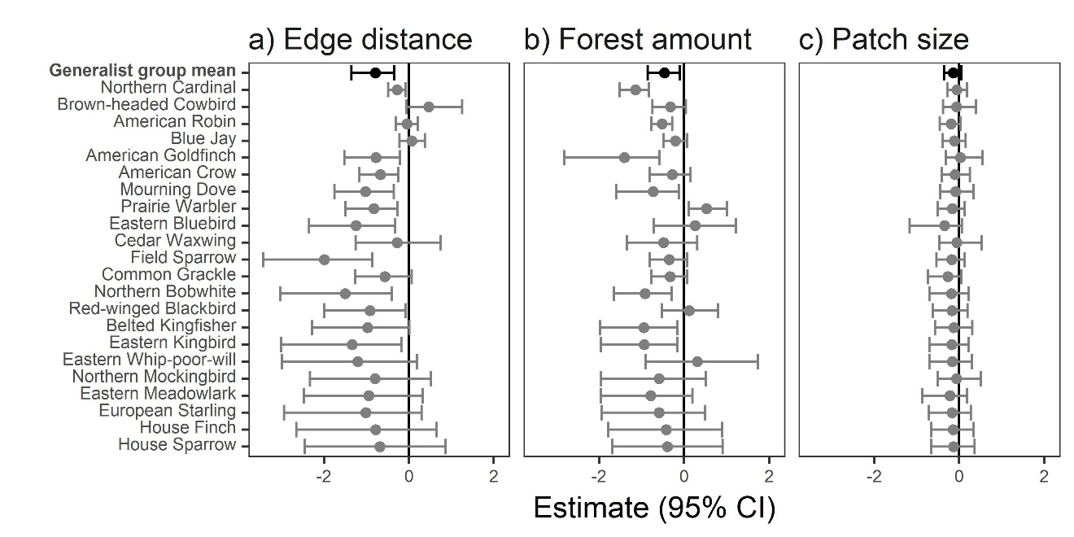
Figure S1.7. Posterior means and 95% credible intervals for the effects of a) edge distance, b) amount of forest within 2 km, and c) log-transformed patch size on probability of occupancy for habitat generalists detected during our point count surveys. These parameter estimates were generated from a community occupancy model that included all 74 species adequately sampled by point counts. The fitting procedure for this model was identical to that presented in the methods section of this paper, except that we added this additional group of 22 habitat generalists. Because forest amount and patch sizes are not biologically relevant metrics of available habitat for these species, we excluded them from consideration in the main document. Species are listed from most common (top) to least common, or equivalently, from most influential on the group mean estimate, to least. Note that all covariates were standardized with a mean of 0 and a standard deviation of 1 prior to model fitting.

